Car Selling Vehicles Requirements Specification

Version 1.0

2024

Description of the system

A car seller company specializes in buying and selling vehicles. The inventory will include a wide range of vehicles up to luxury cars. Our system will be applicable on a car seller shop as well as it would be an online e-commerce site. On the site, customers will be able to browse on different cars and choose the one they want to buy and on the shop they will be able to do test drives etc. On the site, the managers will be able to see different filters or statistics based on the cars sold. Employees such as sales reps will be able to guide and instruct the customers through the features of the cars. If a customer decides to buy a certain car on the shop they can use the e commerce platform to make transactions etc.

User Requirements

* The customer is able to purchase a car via the e-commerce site where he can browse the different cars and then pay the car online. (Edmir Kasapi)
* The customer can purchase the vehicle from the shop and the payment process can be done through the e-commerce site. (Aldi Begaj)
* The supplier is informed from the system when a requested car is out of stock and he needs to provide information to the customer when it can be available. (Elisai Muraci)
* The inventory manager should add new cars to the site and update their specifications.(Albina Kazia)
* The managers have access to monthly analytics to track key measures such as total sales, top-selling vehicles etc. (Irida Lala)
* The finance department(payment processors & economists) should look after the payment process to make sure that taxes are calculated correctly etc. (Daniela Shahini)
* The sales representatives should communicate with the client whenever they have questions about the vehicle on the e-commerce site or even on the shop. (Daniela Shahini)
* The marketing team is responsible for running ads and promotions on the site.(Olsi Llavanji)

Actors in the system

1.Customers: Individuals or businesses looking to buy cars.

2.Sales Representatives: Employees tasked with selling cars at the dealership rely on the system to access customer information, manage leads, schedule appointments, and track sales performance.

3.Management: This includes executives, managers, and administrators within the dealership who use the system to monitor overall performance, analyze sales data, set targets, and make strategic decisions.

4.Finance Department: The finance team uses the system to handle financial transactions related to car sales, such as processing payments etc. (payment processors are included here)

5.Inventory Managers: These stakeholders are responsible for maintaining accurate records of available vehicles, updating inventory levels, and ensuring that the system reflects the current stock of cars.

6.Marketing Team: The marketing department may use the system to analyze customer data, manage marketing campaigns, track leads, and evaluate the effectiveness of advertising efforts.

7.Suppliers: Suppliers of cars, parts, and accessories may have a stake in the system to monitor orders, manage inventory levels, and coordinate deliveries.

8.Regulatory Authorities: Depending on the jurisdiction, regulatory bodies may have an interest in the system to ensure compliance with industry regulations, particularly regarding sales practices, consumer protection, and data privacy.

ALBINA KAZIA

System Requirements

### 1 - Adding New Cars

|  |  |
| --- | --- |
| **Field Name** | **Description** |
| **UC Name** | Adding New Cars |
| **Summary** | This use case involves the inventory manager adding new cars to the platform by providing relevant details such as make, model, condition, etc., through a dedicated interface or dashboard. |
| **Dependency** | None (this use case does not depend on other use cases). |
| **Actors** | Primary Actor: Inventory Manager |
| **Predictions** | The platform must be operational and accessible to the inventory manager. |
| **Preconditions** | The inventory manager must be authenticated and authorized to access the platform. |
| **Description of Main Sequence** | 1. The inventory manager accesses the dedicated interface or dashboard.  2. The manager inputs relevant details about the new car, including make, model, condition, body type, transmission type, fuel type, build date, description, price, and pictures.  3. The platform validates the input data to ensure completeness and accuracy.  4. If the validation is successful, the new car is added to the inventory.  5. If validation fails, the platform prompts the manager to correct any errors in the input data. |
| **Description of Alternative Sequence** | None (no alternative sequences defined for this use case). |
| **Non-functional requirements** | Performance: The platform should be able to handle concurrent requests from multiple inventory managers efficiently. Security: Access to the interface or dashboard for adding new cars should be restricted to authorized inventory managers only. Usability: The interface or dashboard should be user-friendly and intuitive, facilitating easy data entry for the inventory manager. |
| **Postconditions** | The new car is successfully added to the inventory if validation is successful. |
| **Field Name** | **Description** |

### 2 - Updating Car Specifications

|  |  |
| --- | --- |
| **Field Name** | **Description** |
| **UC Name** | Updating Car Specifications |
| **Summary** | This use case involves the inventory manager updating the specifications of existing cars in the inventory, including details such as make, model, condition, etc. |
| **Dependency** | None (this use case does not depend on other use cases). |
| **Actors** | Primary Actor: Inventory Manager |
| **Predictions** | The platform must be operational and accessible to the inventory manager. |
| **Preconditions** | The inventory manager must be authenticated and authorized to access the platform. |
| **Description of Main Sequence** | 1. The inventory manager accesses the platform.  2. The manager locates and selects the car whose specifications need to be updated.  3. The manager modifies the necessary details such as make, model, condition, transmission type, fuel type, build date, description, price, and pictures. 4. The platform validates the updated data to ensure completeness and accuracy.  5. If validation is successful, the changes are applied to the selected car in the inventory.  6. If validation fails, the platform prompts the manager to correct any errors in the updated data. |
| **Description of Alternative Sequence** | None (no alternative sequences defined for this use case). |
| **Non-functional requirements** | Performance: The platform should provide fast response times when retrieving and updating car specifications. Security: Access to the interface or dashboard for updating car specifications should be restricted to authorized inventory managers only. Usability: The interface or dashboard should be intuitive and user-friendly, facilitating easy navigation and data entry for the inventory manager. |
| **Postconditions** | The specifications of the selected car are successfully updated in the inventory if validation is successful. |
| **Field Name** | **Description** |

3 - Managing Inventory

|  |  |
| --- | --- |
| **Field Name** | **Description** |
| **UC Name** | Managing Inventory |
| **Summary** | This use case involves the inventory manager accessing a comprehensive dashboard to view all cars currently in stock. The dashboard displays relevant information such as make, model, condition, availability, and price. The manager can filter and search through the inventory based on different criteria. |
| **Dependency** | None (this use case does not depend on other use cases). |
| **Actors** | Primary Actor: Inventory Manager |
| **Predictions** | The platform must be operational and accessible to the inventory manager. |
| **Preconditions** | The inventory manager must be authenticated and authorized to access the platform. |
| **Description of Main Sequence** | 1. The inventory manager accesses the platform and navigates to the inventory dashboard.  2. The dashboard displays a list of all cars currently in stock, along with relevant information such as make, model, condition, availability, and price.   3. The manager utilizes filtering and search functionalities to narrow down the inventory based on criteria such as make, model, condition, and availability.   4. The platform updates the displayed inventory in real-time as per the manager's filtering and search criteria. |
| **Description of Alternative Sequence** | None (no alternative sequences defined for this use case). |
| **Non-functional requirements** | Performance: The platform should provide fast response times when loading and updating inventory data. Security: Access to the inventory management dashboard should be restricted to authorized inventory managers only. Usability: The dashboard should be user-friendly and intuitive, facilitating easy navigation and data exploration for the inventory manager. |
| **Postconditions** | The inventory manager successfully views and manages the inventory based on their filtering and search criteria. |

4-Inventory Analytics:

|  |  |
| --- | --- |
| **Field Name** | **Description** |
| **UC Name** | Inventory Analytics |
| **Summary** | This use case involves providing analytics tools to the inventory manager to monitor stock levels, track sales performance, and identify trends. These analytics include reports on popular car models, sales trends over time, inventory turnover rates, and more. The inventory manager can utilize these insights to make informed decisions about inventory management and procurement. |
| **Dependency** | None (this use case does not depend on other use cases). |
| **Actors** | Primary Actor: Inventory Manager |
| **Predictions** | The tools must be operational and accessible to the inventory manager. |
| **Preconditions** | The inventory manager must be authenticated and authorized to access the analytics tools. |
| **Description of Main Sequence** | 1. The application provides various analytics tools, including reports on stock levels, sales performance, and trends. 2. The manager selects the desired analytics tool or report to view. 3. The application generates and displays the requested analytics report. 4. The manager analyzes the report to gain insights into inventory management and procurement decisions. |
| **Description of Alternative Sequence** | None (no alternative sequences defined for this use case). |
| **Non-functional requirements** | Performance: The application should provide fast response times when generating and displaying analytics reports. Security: Access to the analytics tools should be restricted to authorized inventory managers only. Usability: The analytics tools should be user-friendly and intuitive, facilitating easy navigation and data interpretation for the inventory manager. |
| **Postconditions** | The inventory manager successfully views and utilizes the analytics reports to make informed decisions about inventory management and procurement. |
| **Field Name** | **Description** |

5 - Notifications and Alerts

|  |  |
| --- | --- |
| **Field Name** | **Description** |
| **UC Name** | Notifications and Alerts |
| **Summary** | This use case involves notifying the inventory manager about important events such as low stock levels, out-of-stock items, or new orders. Notifications can be sent via email, SMS, or through the platform's dashboard to ensure timely action. |
| **Dependency** | None (this use case does not depend on other use cases). |
| **Actors** | Primary Actor: Inventory Manager |
| **Predictions** | The platform must be operational and capable of sending notifications through email, SMS, or the dashboard. |
| **Preconditions** | The inventory manager must be authenticated and authorized to receive notifications. |
| **Description of Main Sequence** | 1. The platform monitors for important events such as low stock levels, out-of-stock items, or new orders. 2. When an event occurs, the platform generates a notification. 3. The notification is sent to the inventory manager via the selected communication channel (email, SMS, or dashboard). 4. The inventory manager receives the notification and takes appropriate action. |
| **Description of Alternative Sequence** | None (no alternative sequences defined for this use case). |
| **Non-functional requirements** | Performance: Notifications should be delivered promptly to ensure timely action by the inventory manager. Security: Access to sensitive notifications should be restricted to authorized inventory managers only. Reliability: The notification system should be reliable, with minimal downtime or failures in delivering notifications. |
| **Postconditions** | The inventory manager successfully receives and responds to notifications regarding important events. |

ALBINA KAZIA

Activity Diagrams

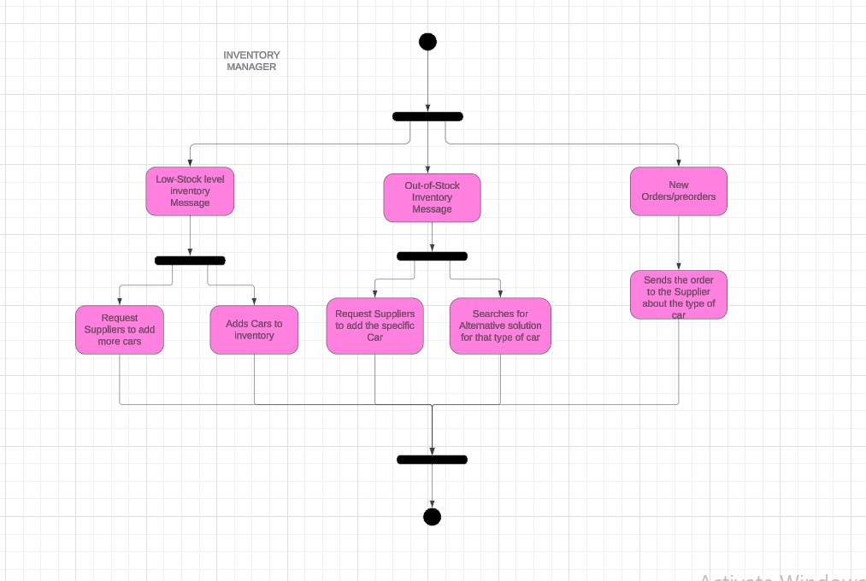

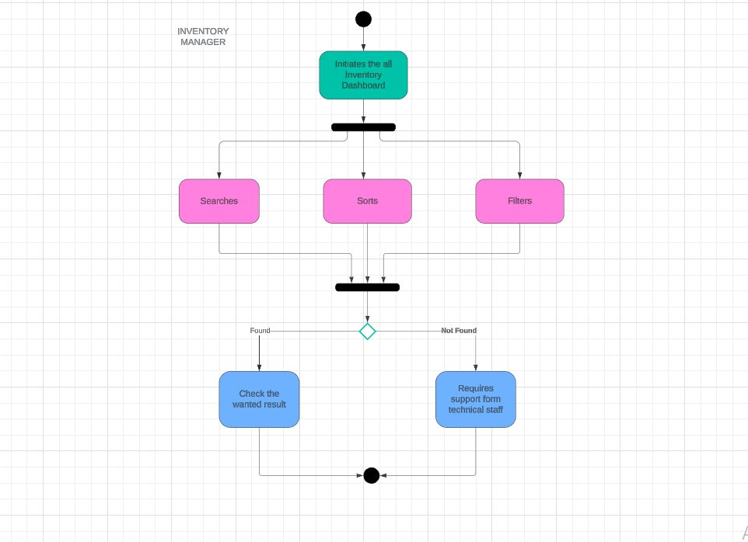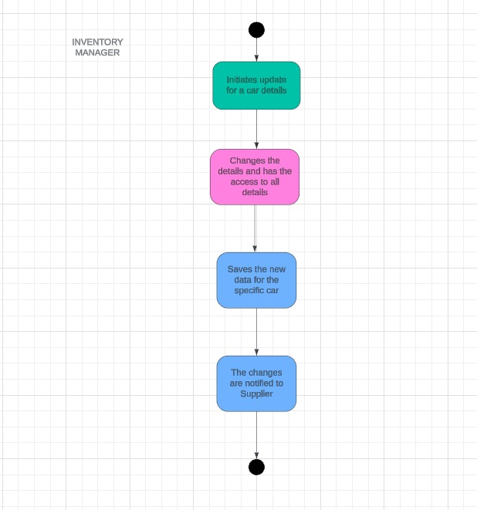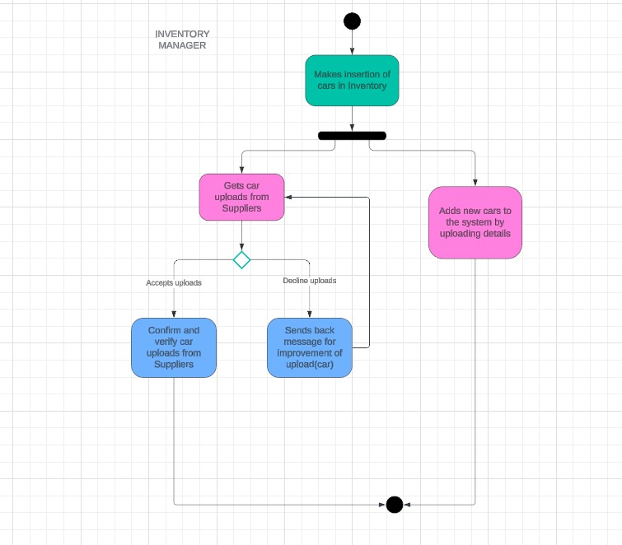

ALBINA KAZIA

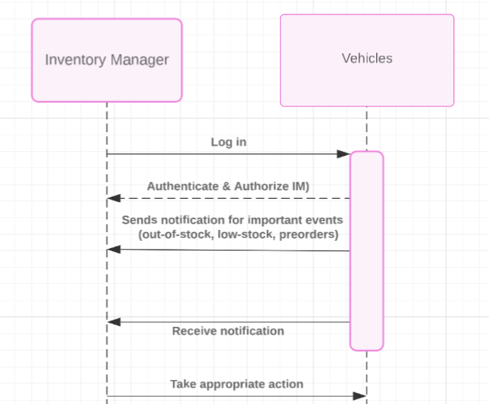Sequence Collaboration Diagrams

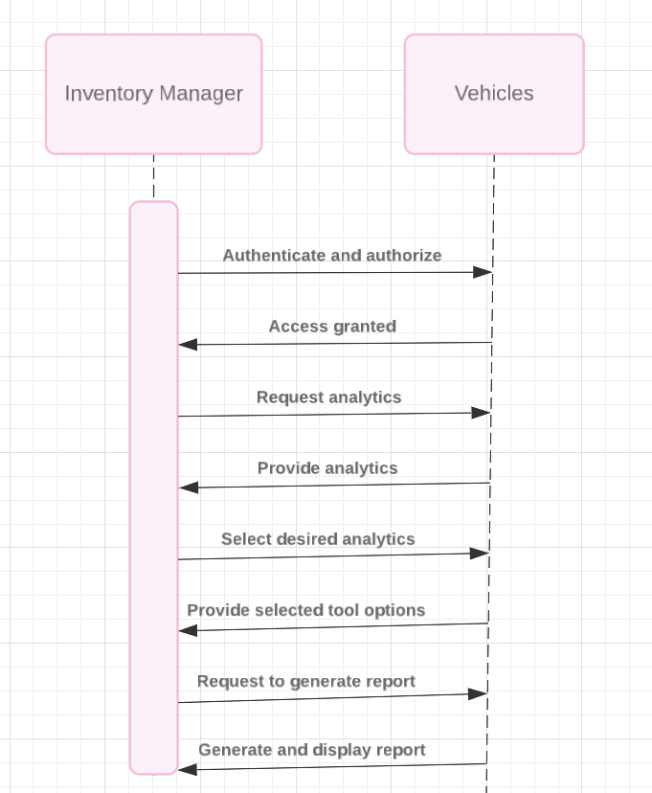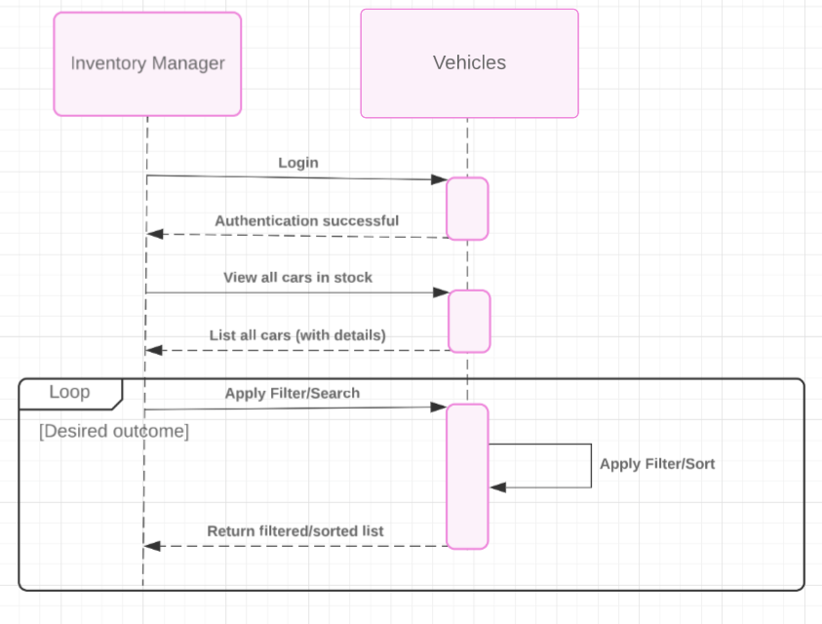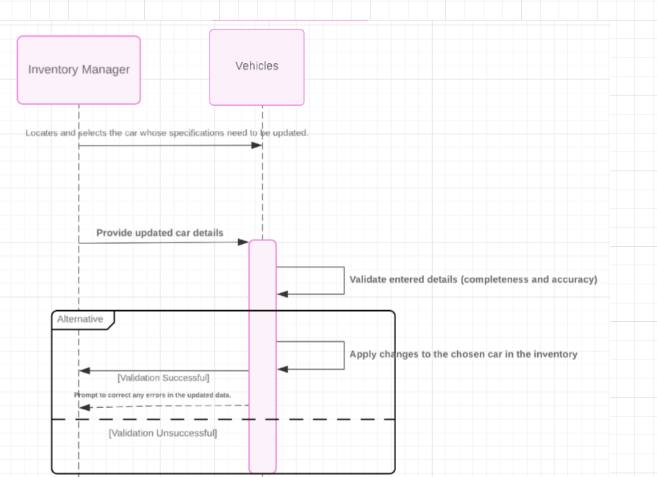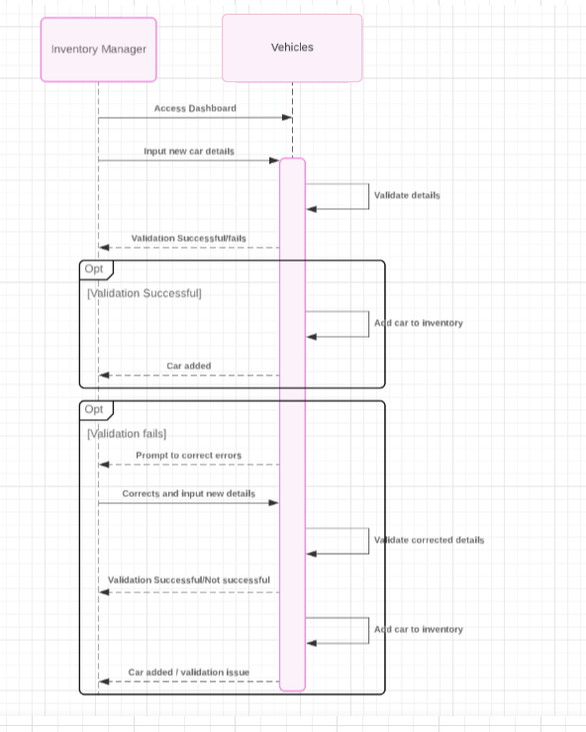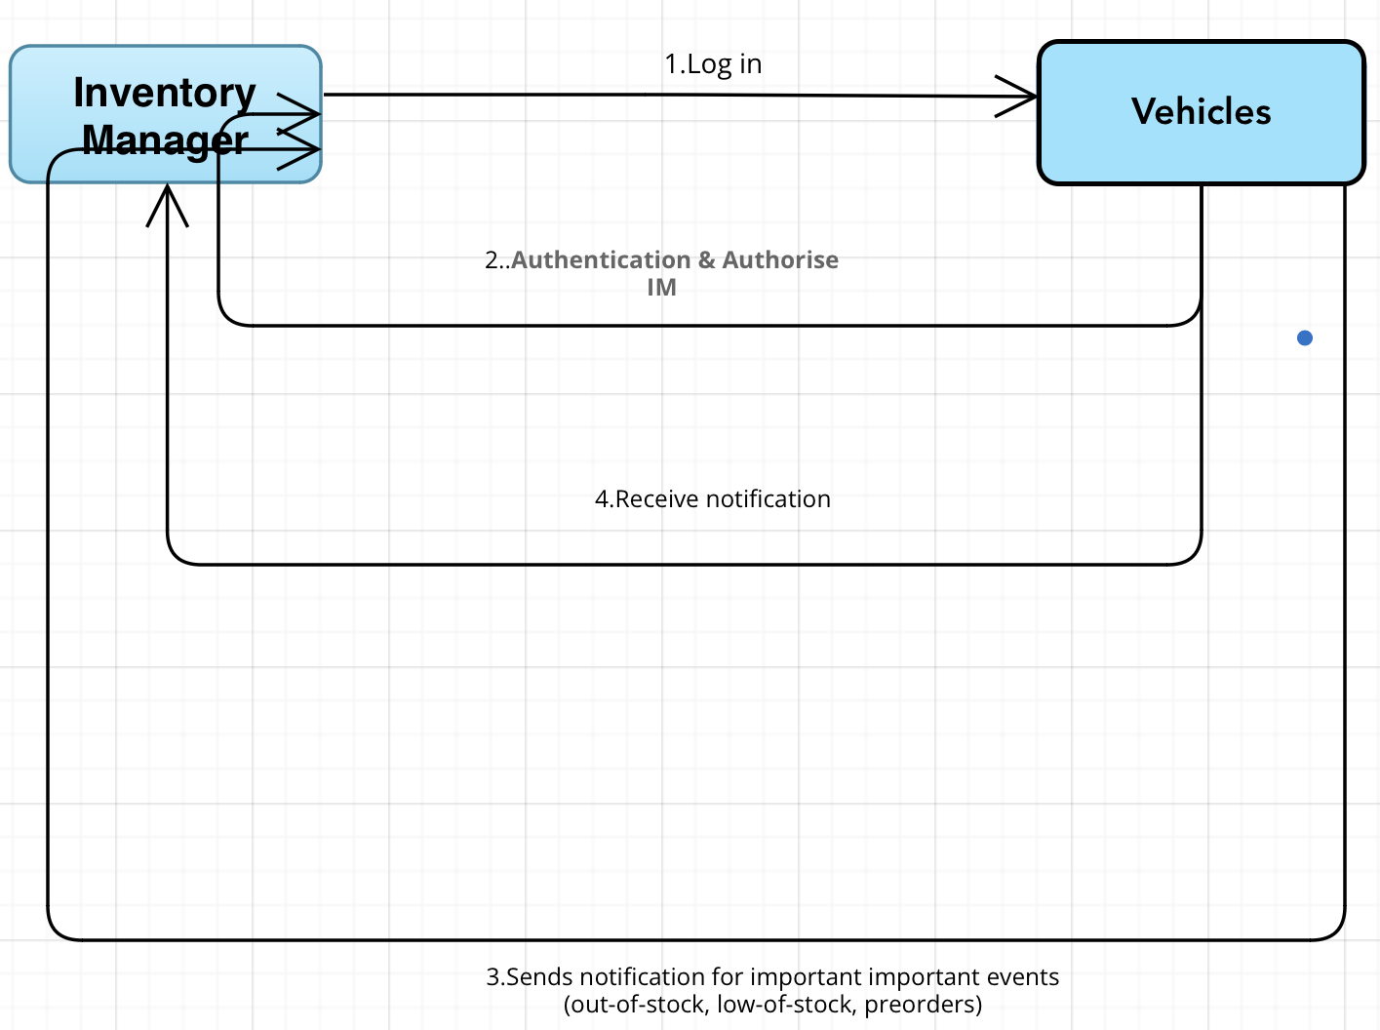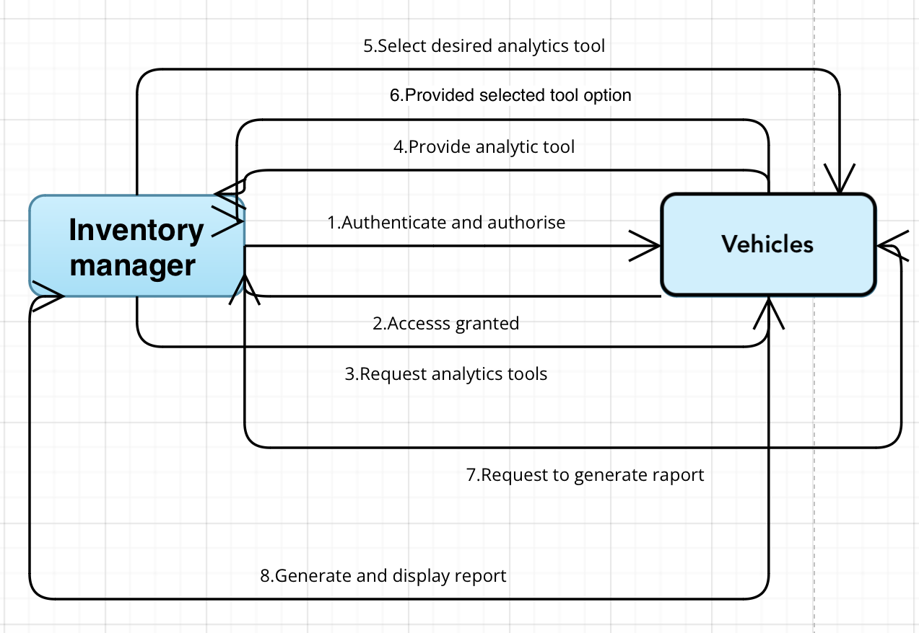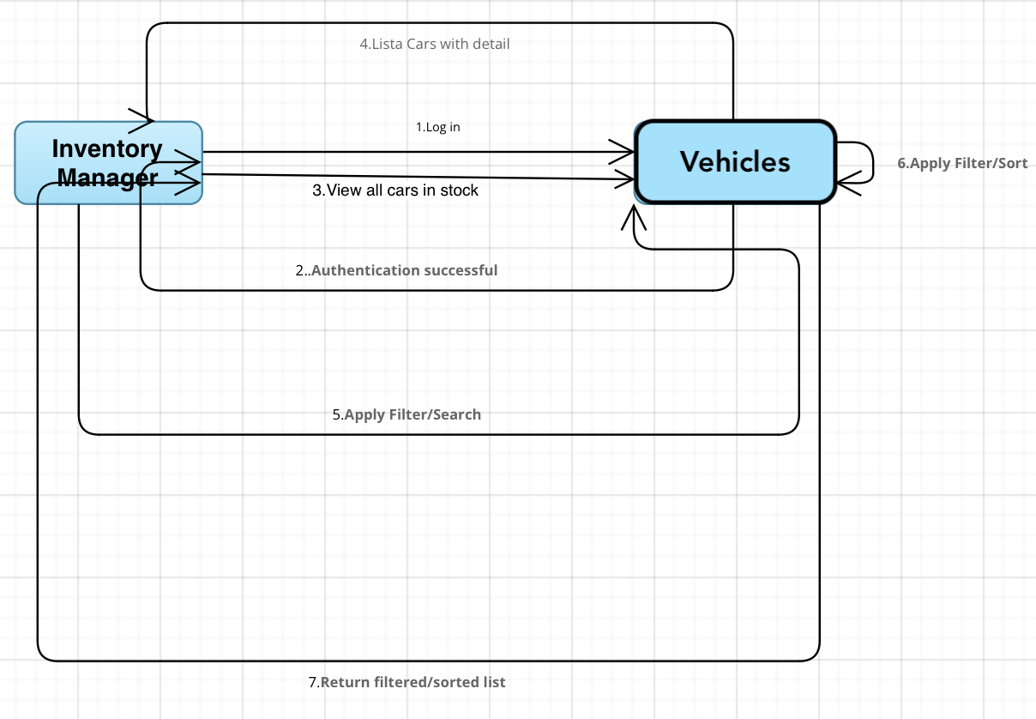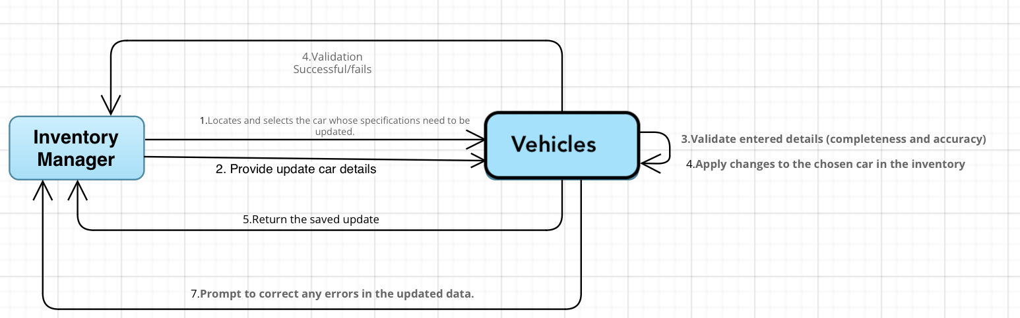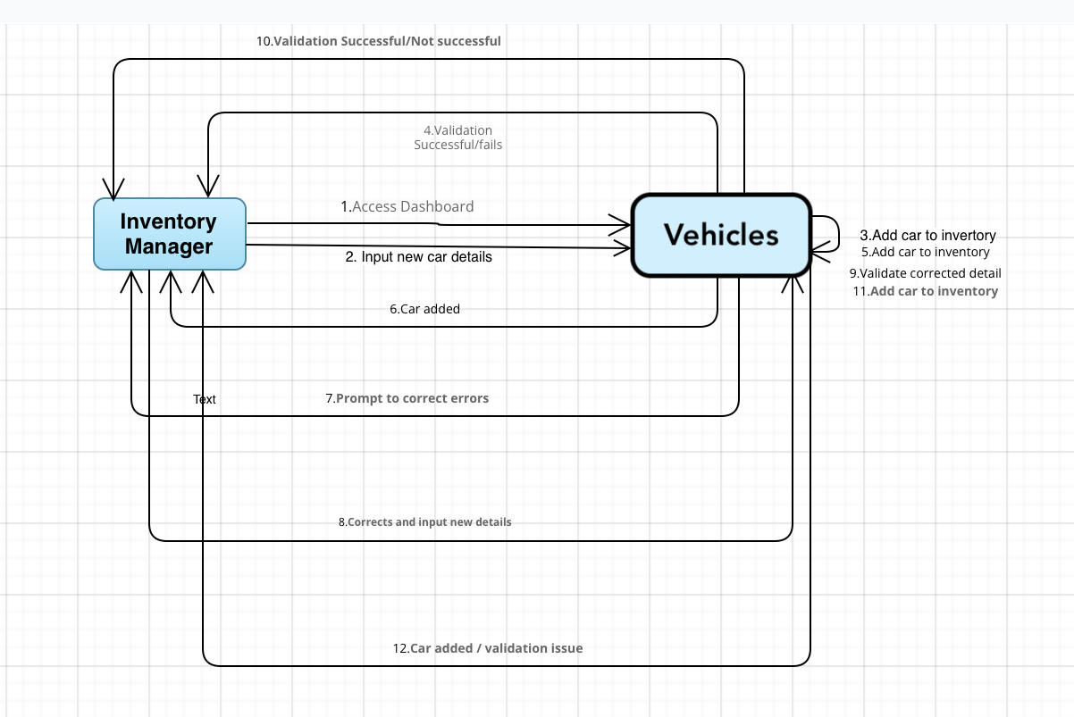

DANIELA SHAHINI

System Requirements

User Requirement - The finance department (payment processors & economists) should look after the payment process to make sure that taxes are calculated correctly etc.

|  |  |
| --- | --- |
| UC Name | *UC-F1 – Calculate taxes* |
| Summary | *The system should calculate taxes for the car bought online and on the shop.* |
| Dependency | *This use case depends on the type of car chosen.* |
| Actors | *The primary actor is the System itself.* |
| Preconditions | *The vehicle should be selected.*  *If its free shipping then no additional taxes are added. (bought the car on the shop)*  *If we buy the car online then taxes on shipping are calculated.* |
| Description of the Main Sequence | * *A user goes to the payment page after he selected a vehicle;* * *On the payment page, taxes are calculated and displayed to the customer.* * *Order is made successfully.* |
| Description of the Alternative Sequence | * *The taxes fail to be calculated.* * *An error message is displayed to the user, like “Try again later”.* |
| Non-functional requirements | *The taxes should be calculated at a high speed ensuring site performance.*  *The taxes retrieved should be accurate in order to avoid errors and discrepancies in tax amounts.* |
| Postconditions | *The taxes were displayed and calculated correctly.* |

User Requirement - The finance department (payment processors & economists) should look after the payment process to make sure that taxes are calculated correctly etc.

|  |  |
| --- | --- |
| UC Name | *UC-F2 – Integration with Tax Authorities* |
| Summary | *The system should be integrated with Tax Authorities API in order to calculate taxes based on different vehicle.* |
| Dependency | *This use case depends on the UC-F1.* |
| Actors | *The primary actor are the Tax Authorities.* |
| Preconditions | *The system must be integrated with the API from tax authorities.* |
| Description of the Main Sequence | * *The system is integrated with the Tax API* * *The system retrieves the taxes value based on the vehicle selected.* |
| Description of the Alternative Sequence | * *The system fails to retrieve the taxes.* * *On FE, a warning error is displayed.* |
| Non functional requirements | *The system should provide high security in order to ensure compliance with data protection regulations.* |
| Postconditions | *The system is successfully integrated with tax authorities.* |

|  |  |
| --- | --- |
| UC Name | *UC-F3 – Audit Integration* |
| Summary | *The system should display the orders and their taxes. Since we operate as a business, taxes will be all gathered and paid at a certain time. Their sum should be shown by the system for the managers to be informed.* |
| Dependency | *This use case depends on the orders made.* |
| Actors | *The primary actor is the Manager.* |
| Preconditions | *The system must be integrated with the API.*  *Some order must be made.* |
| Description of the Main Sequence | * *Customer selects a vehicle.* * *The taxes are calculated for that vehicle.* * *Order is made.* * *Order and its taxes are displayed on the admin dashboard.* * *Taxes are added to the sum of taxes.* |
| Description of the Alternative Sequence | * *Order fails to be displayed on the dashboard.* * *Taxes are not added to the sum.* |
| Non functional requirements | *The system should provide high security in order to ensure compliance with data protection regulations.* |
| Postconditions | *The taxes are successfully added to the sum.* |

User Requirement - The sales representatives should communicate with the client whenever they have questions about the vehicle on the e-commerce site or even on the shop.

|  |  |
| --- | --- |
| UC Name | *UC-S1 – Communication Hub* |
| Summary | *The system should display a communication hub for Q&A to help the customers.* |
| Dependency | *-* |
| Actors | *The primary actor are the System Itself.* |
| Preconditions | *The site should be live all the time for the communication hub to be displayed.* |
| Description of the Main Sequence | * *A user enters the site.* * *The user is unclear about a certain vehicle and wants more information.* * *He types in the comms hub that he has a question.* * *AI generates a response or AI will ask for their contact info for the sales reps to contact the customer.* |
| Description of the Alternative Sequence | * *The communication hub fails to be displayed.* |
| Non functional requirements | *The system should protect the site from hackers from writing unauthorized codes on the input of the hub.* |
| Postconditions | *The communication hub is successfully displayed.* |

User Requirement - The sales representatives should communicate with the client whenever they have questions about the vehicle on the e-commerce site or even on the shop.

|  |  |
| --- | --- |
| UC Name | *UC-S2 – AI Integration* |
| Summary | *The system should be integrated with AI bots in order to answer questions faster.* |
| Dependency | *-* |
| Actors | *The primary actor is the AI bot.* |
| Preconditions | *The system must be integrated with AI.* |
| Description of the Main Sequence | * *The system is integrated with the AI bot.* * *The AI bots are functional to answer questions or to ask for contact info.* |
| Description of the Alternative Sequence | * *The AI bots fail to respond.* * *An error message like “Please contact this number for more info will be displayed.”* |
| Non functional requirements | *The AI’s response time should be fast enough and it should use resources efficiently.*  *The AI should adhere to relevant communication protocols.* |
| Postconditions | *The AI bots have successfully answered the customer’s questions.* |

|  |  |
| --- | --- |
| UC Name | *UC-S3 – Communicating with Sales Representatives* |
| Summary | *The system should allow sales reps to contact the customer and answer question.* |
| Dependency | *This use case depends on UC-S1, US-S2* |
| Actors | *The primary actors are the Sales Representatives.* |
| Preconditions | *The AI bots should have asked for a contact information of the customer that has questions.* |
| Description of the Main Sequence | * *AI is not able to generate a response so it asks for a contact info of the customer.* * *The sales reps are alerted and they contact the customer.* |
| Description of the Alternative Sequence | * *Alerts are not sent to the sales reps.* |
| Non functional requirements | *The alerts should be sent immediately to ensure high performance and customer satisfaction.* |
| Postconditions | *The sales reps have successfully reached out to the customer to provide him answers.* |

DANIELA SHAHINI

Activity Diagrams

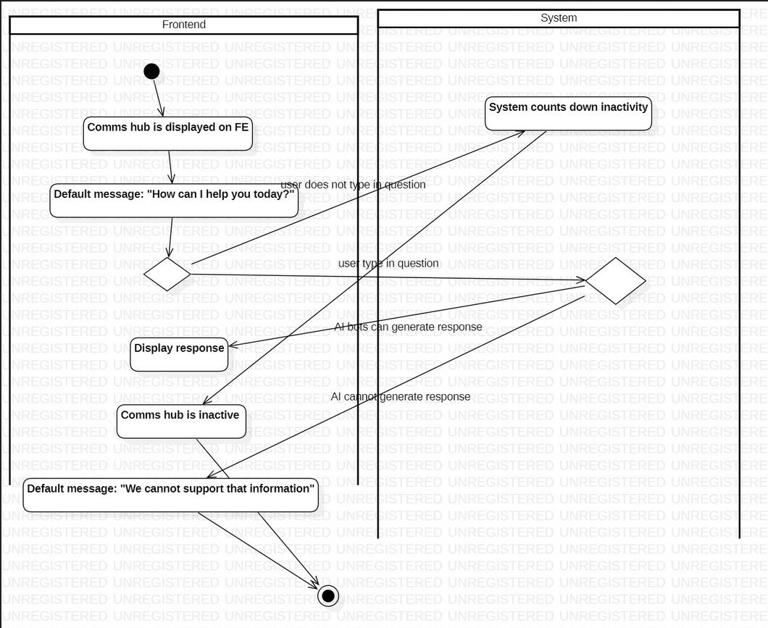

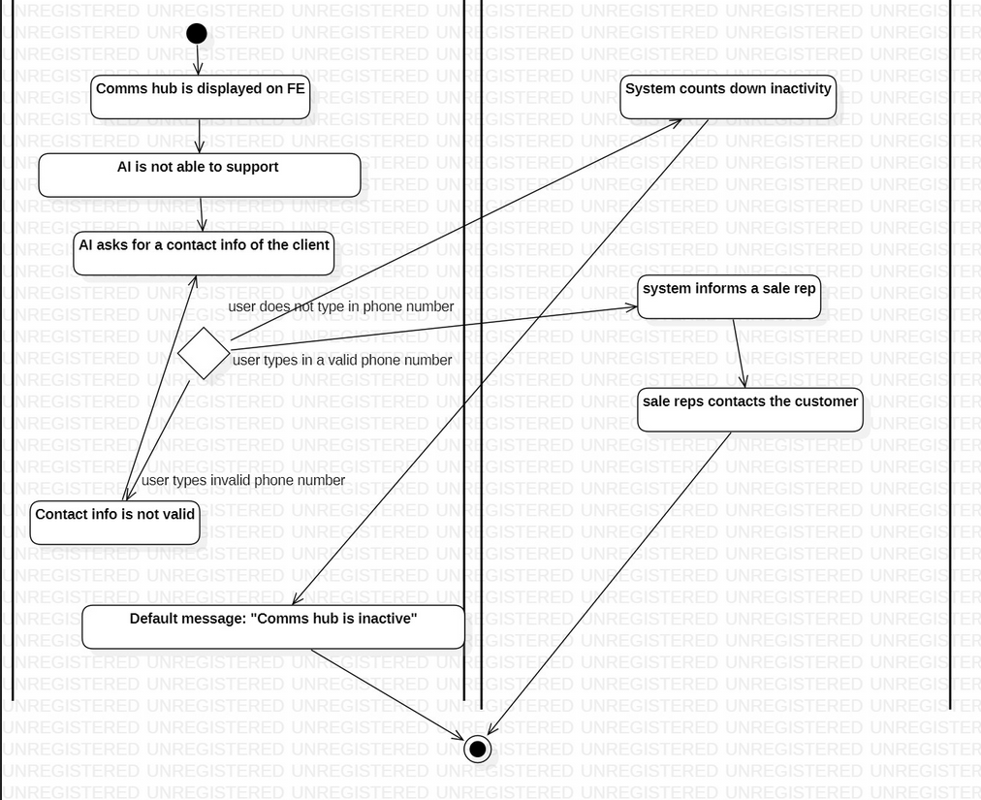

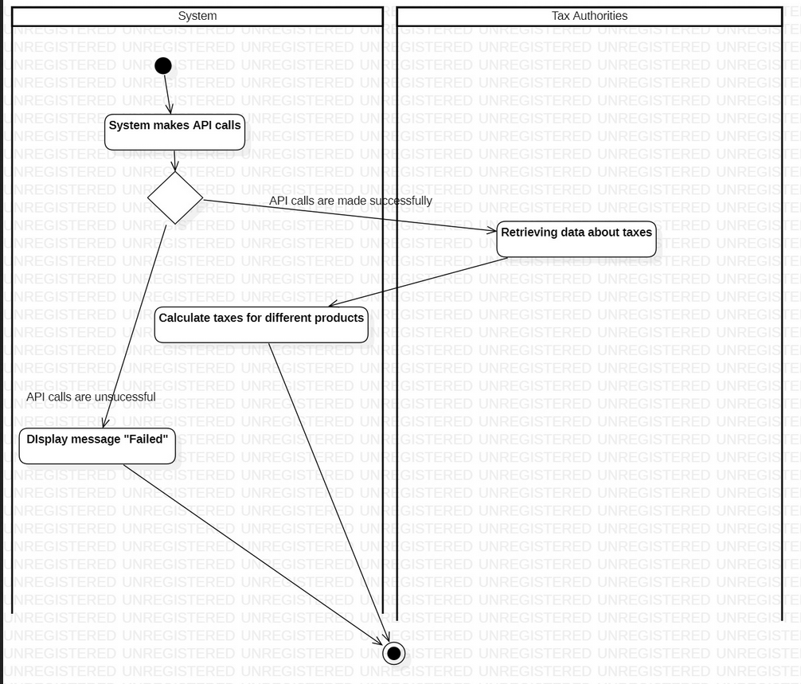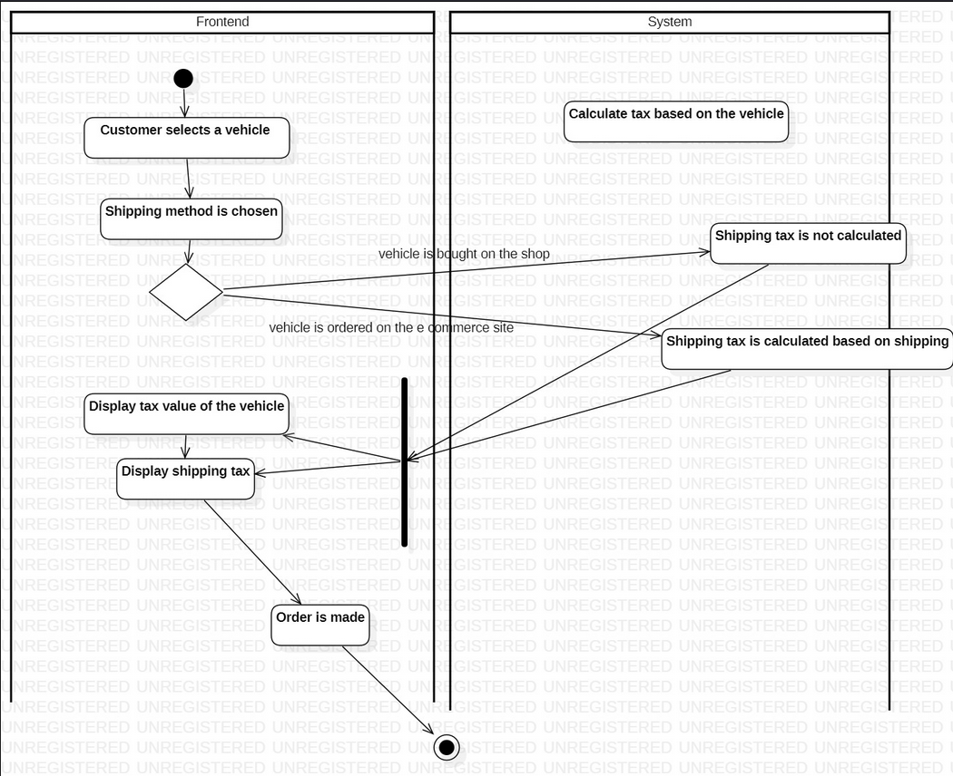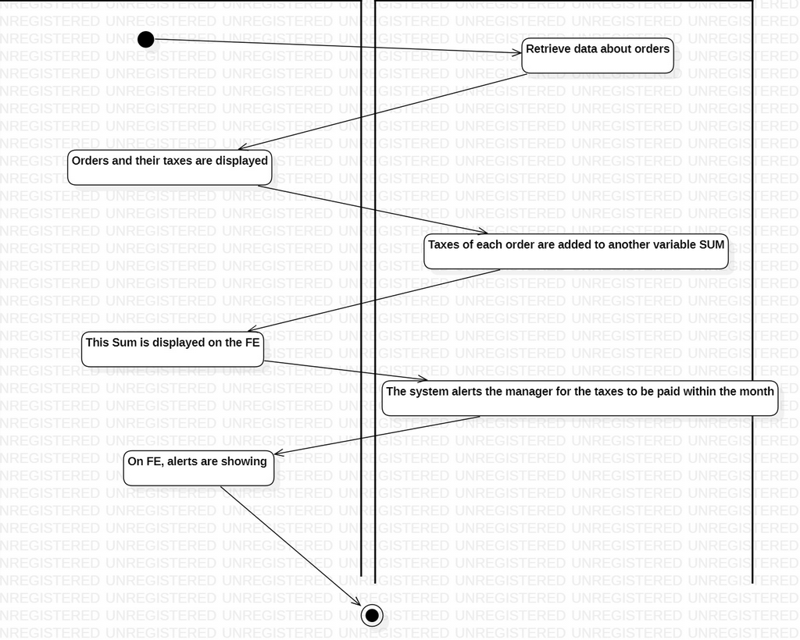

DANIELA SHAHINI

Sequence Collaboration Diagrams

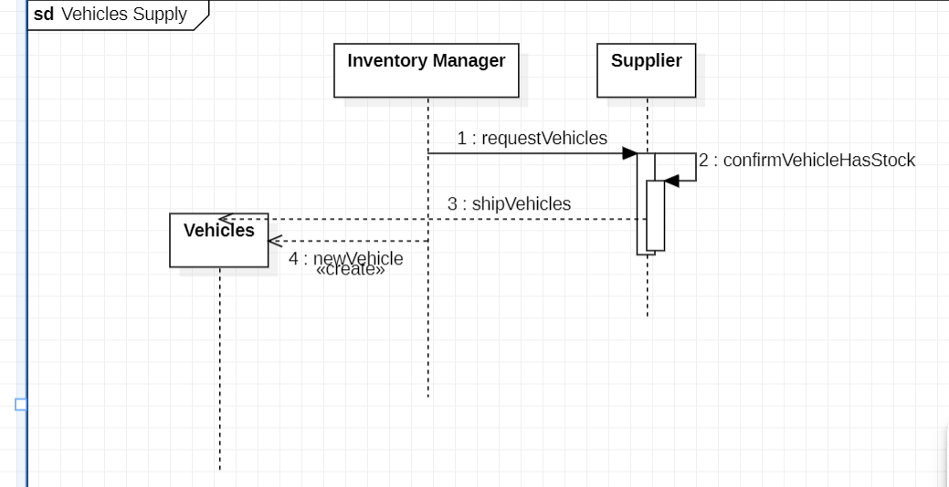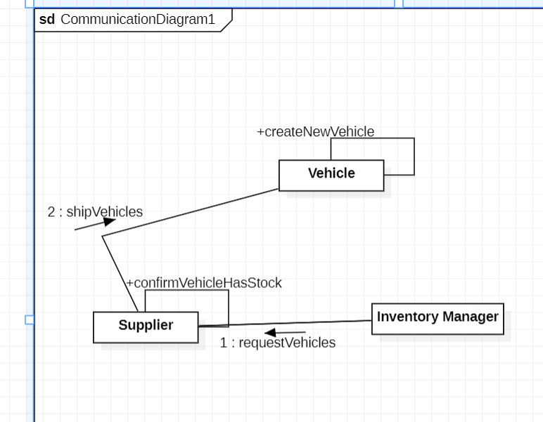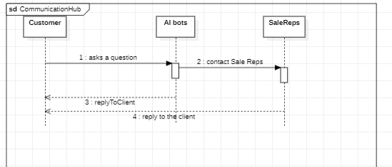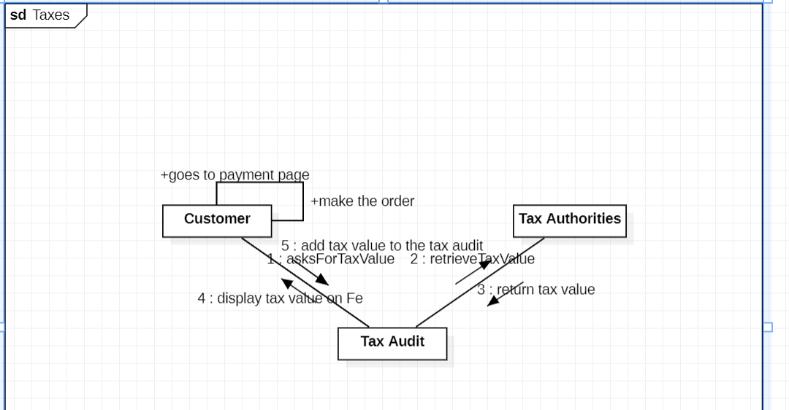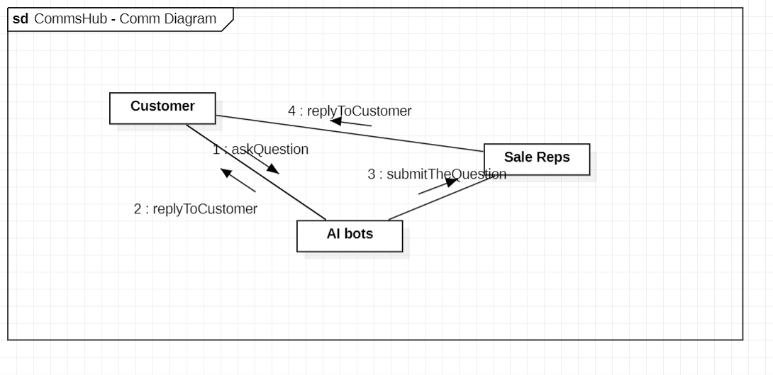

EDMIR KASAPI

System Requirements

The customer is able to purchase a car via the e-commerce site where he can browse the different cars and then pay the car online.

|  |  |
| --- | --- |
| **UC Name** | UC-SC2 Filtering/Sorting the vehicle list |
| Summary | The system allows the customer to:  -Sort the vehicles in ascending or descending order based on their price or build date  -Filter out vehicles based on their qualities such as transmission type, condition, body type, etc. |
| Dependency | No dependency |
| Actors | -Customer |
| Preconditions | -The customer must be logged in by entering the appropriate credentials.  -The system must have an operational database filled with the appropriate data. |
| Description of the main sequence | 1.The customer logs in to the e-commerce site.  2.The customer selects an option to filter the vehicles.  3.The system displays the tags available to filter the vehicle list.  4.The customer selects the “manual” tag on the transmission header of the options.  5.The system displays all vehicles with manual transmission. |
| Description of an alternative sequence | 1.The customer logs in to the e-commerce site.  2.The customer selects the option to sort the vehicles.  3.The system displays the sorting options available.  4.The customer selects the option to sort the vehicles by build date from newest to oldest.  5.The system displays all vehicles sorted in the requested manner. |
| Nonfunctional requirements | -The sorting of the list should be quick and accurate to the customer’s request |
| Postconditions | A list of vehicles is displayed to the customer sorted in the way they requested. |

|  |  |
| --- | --- |
| **UC Name** | UC-SC1 Browsing the car catalog |
| Summary | The system allows the user to search for vehicles by entering the make and model  (or either one of them) on the search bar. |
| Dependency | No dependency |
| Actors | -Customer |
| Preconditions | -The customer must have a registered account and should be logged in by entering the appropriate credentials.  -The system must have an operational database filled with the appropriate data  . |
| Description of the main sequence | 1.The customer logs in to the e-commerce site.  2.The customer types the make and model of their desired vehicle on the search bar.  3.The customer clicks the button “search” right next to the search bar.  4.The system displays the vehicles with the make and model entered by the customer.  5.The customer selects one of the displayed vehicles.  6.The customer exits. |
| Description of an alternative sequence | 1.The customer logs in to the e-commerce site.  2.The customer types only the make of their desired vehicle on the search bar and clicks the button ”search”.  3.The system displays all vehicles with the entered make.  4.The customer selects one of the displayed vehicles.  5.The customer exits. |
| Nonfunctional requirements | -The system must respond quickly to customer input.  -The system must display accurate data based on the input given by the customer.  -The interface should be simple and easy to understand. |
| Postconditions | A list of vehicles is displayed to the customer with the vehicles of the make and model they desire. |

|  |  |
| --- | --- |
| **UC Name** | UC-DVI Displaying vehicle information |
| Summary | The system should display basic information about the vehicles such as:   * Make * Model * Condition (Used or new) * Body type * Transmission type * Fuel type * Build date * Description (Optional) * Pictures of the vehicle |
| Dependency | No dependency |
| Actors | -Customer |
| Preconditions | -The customer must have a registered account and should be logged in by entering the appropriate credentials.  -The system must have an operational database filled with the appropriate data. |
| Description of the main sequence | 1.The customer logs in to the e-commerce site.  2.The customer searches for a vehicle.  3.The system displays the appropriate list of vehicles.  5.The customer selects one of the vehicles.  6.The system receives and displays detailed information about the vehicle. |
| Description of an alternative sequence | None |
| Nonfunctional requirements | -The system should provide accurate information about the selected vehicle.  -In the vehicle list, the information should be displayed in the form of icons. |
| Postconditions | The customer can see detailed information about the vehicle selected/displayed on the list. |

|  |  |
| --- | --- |
| **UC Name** | UC-VP1 Purchasing a vehicle |
| Summary | The system should prompt the customer to enter their payment information when they choose to purchase a vehicle and generate a bill which contains the order information. |
| Dependency | UC-SC1 and UC-SC2 |
| Actors | -Customer |
| Preconditions | -The customer has searched for their desired vehicle and is viewing detailed information about said vehicle. |
| Description of the main sequence | 1.The customer clicks the “purchase” button while viewing detailed information about the vehicle.  2.The system prompts the customer to enter their payment information.  3.The customer enters their payment information and clicks a “proceed” button.  4.The system prompts the customer to enter delivery information.  5.The customer enters the delivery information and clicks “proceed”.  4.The system inquires the user if they are sure they want to make the purchase.  5.The customer clicks “yes”.  6.The system stores the order in the orders database with status “pending”.  7.The system notifies the manager about the new order |
| Description of an alternative sequence | 1.The customers selects a vehicle to purchase.  2.The customer proceeds with the payment and delivery information.  3.The system inquires the user if they are sure they want to make the purchase.  4.The customer clicks “No”.  5.The customer is sent back to the vehicle information screen. |
| Nonfunctional requirements | -The system should display accurate pricing of the selected vehicles as well as the total of the entire cart.  -The interface should be intuitive and easy to interact.  -The system should display the price in the selected currency by the customer(Euros/Dollars/ALL).  -The process should be as efficient as possible. |
| Postconditions | The customer has completed their vehicle order and provided appropriate information. The order information is sent to the customer and finance team for confirmation. |

|  |  |
| --- | --- |
| **UC Name** | UC-VP2 Confirming the order |
| Summary | The system should notify the customer if their order was validated. |
| Dependency | UC-VP1 |
| Actors | -Customer  -Finance representative(secondary actor) |
| Preconditions | -The customer has completed the vehicle order. |
| Description of the main sequence | 1.The system sends the order details to the finance team.  2.A finance representative reviews the order made by the customer.  3.The finance representative approves the order.  4.The system validates the order and sends a validation email to the customer. |
| Description of an alternative sequence | 1.The system sends the order details to the finance team.  2.A finance representative reviews the order made by the customer.  3.The finance representative rejects the order.  4.The system deletes the order and sends an email explaining why the order was rejected to the customer. |
| Nonfunctional requirements | -The confirmation email should briefly explain why the order was approved/rejected by the finance team.  -The delivery time of the confirmation email should be as minimal as possible.  -The order details should be displayed with accuracy. |
| Postconditions | A confirmation email is sent to the customer’s email address by the system. The order made by the customer is validated if approved by the finance team. |

EDMIR KASAPI

Activity Diagrams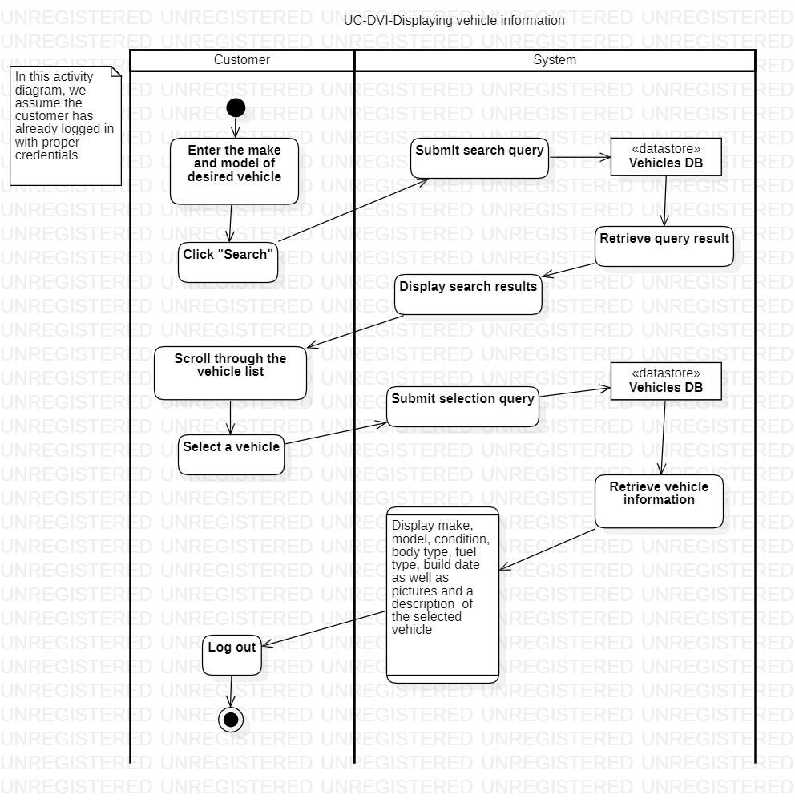

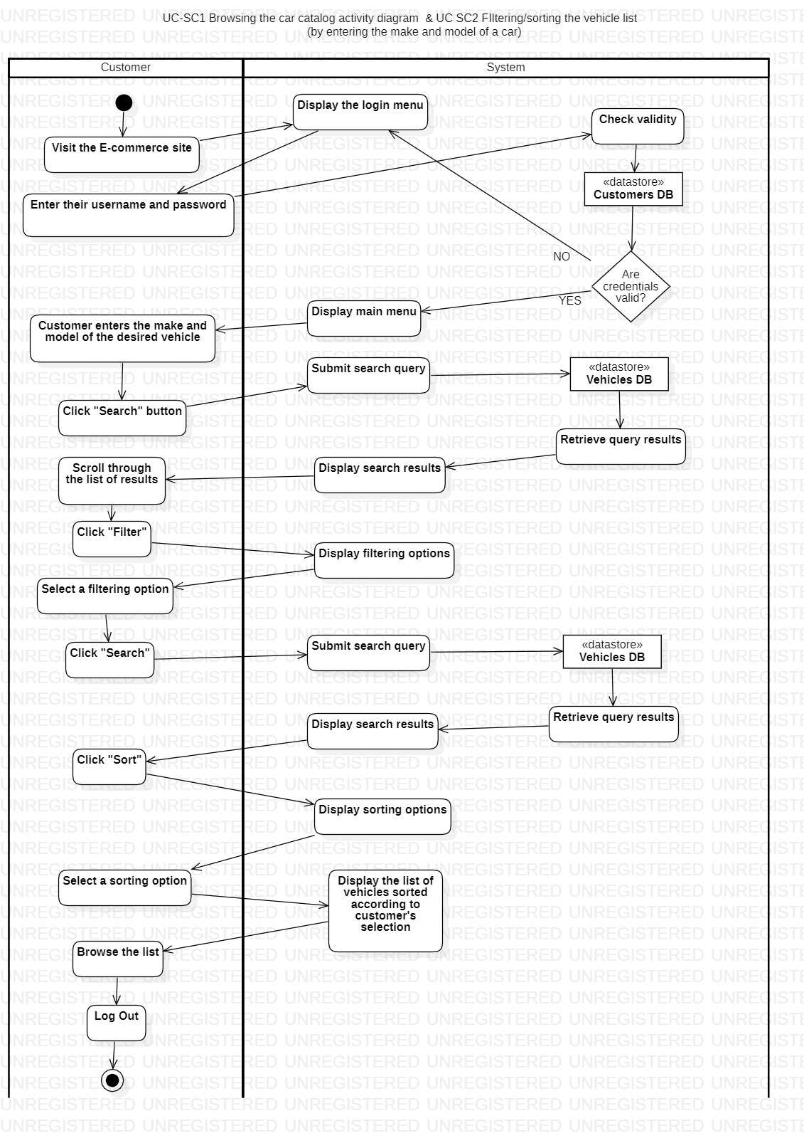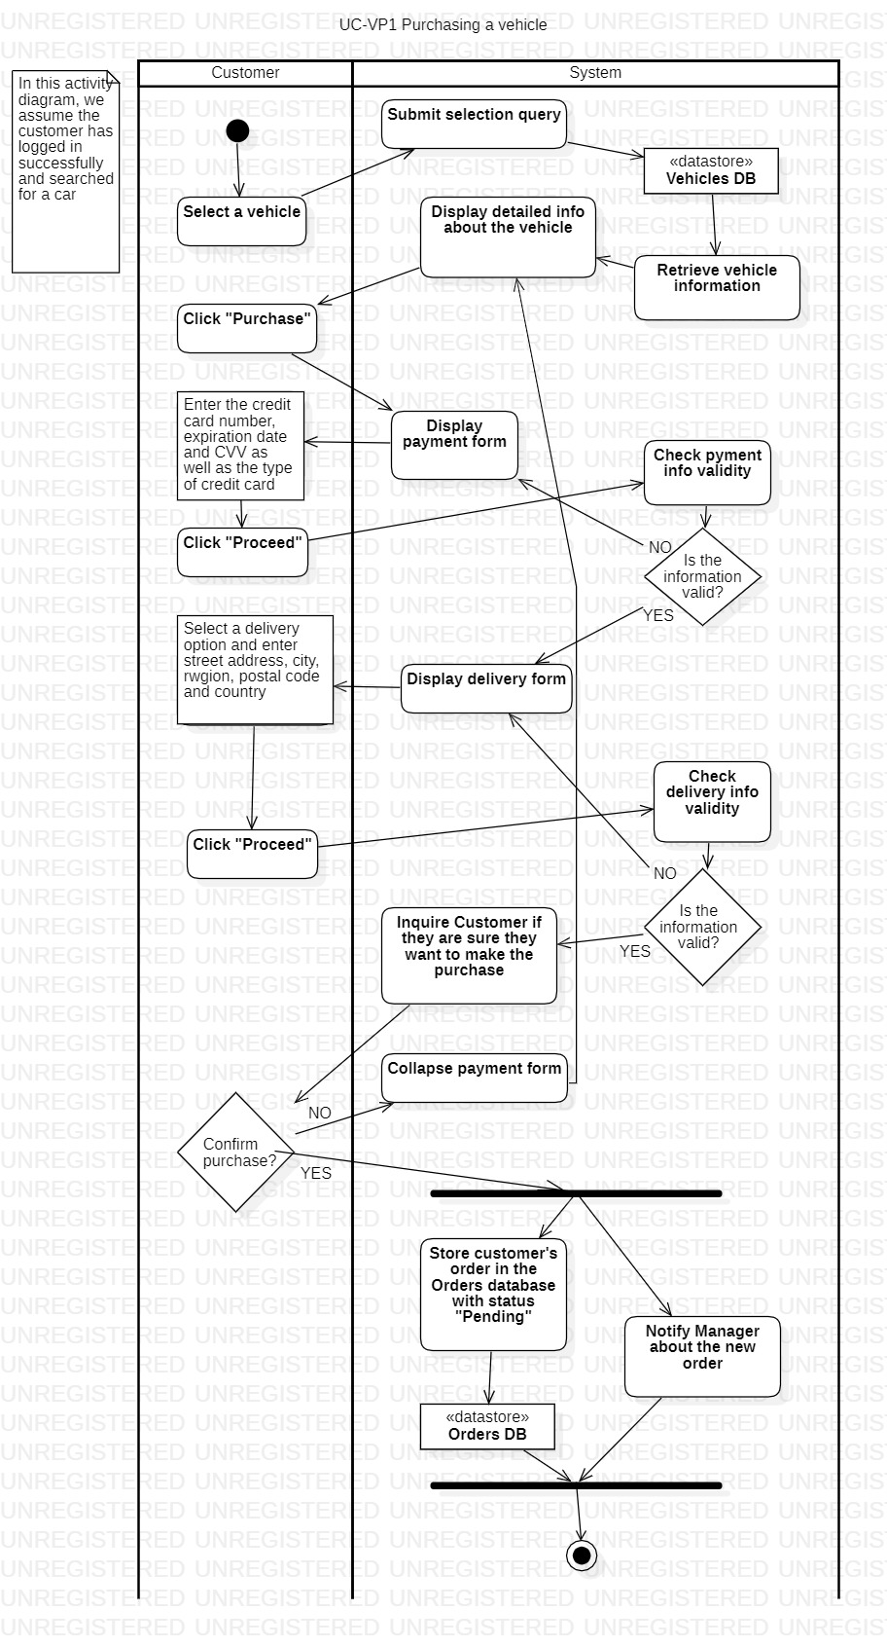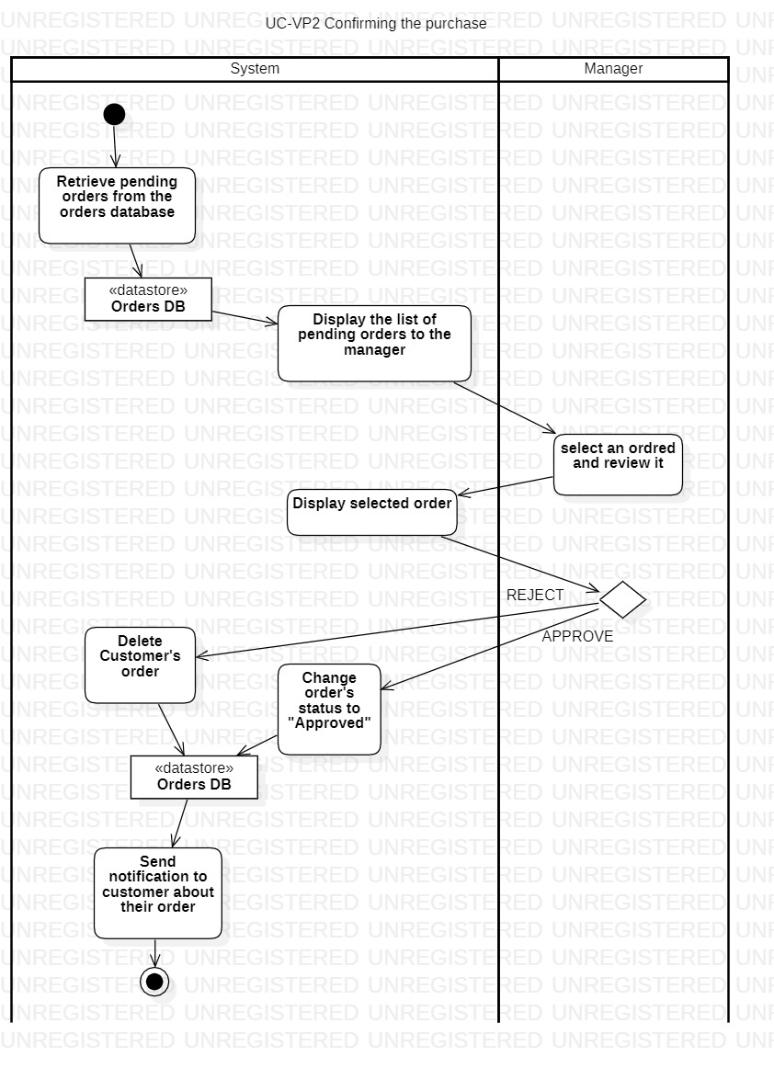

EDMIR KASAPI

Sequence & Collaboration Diagrams

Collaboration Diagrams  
  
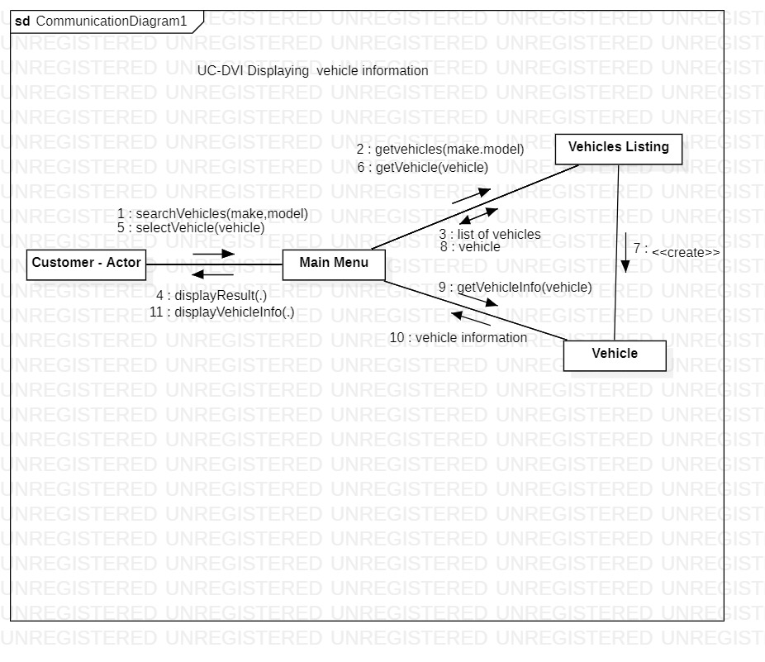

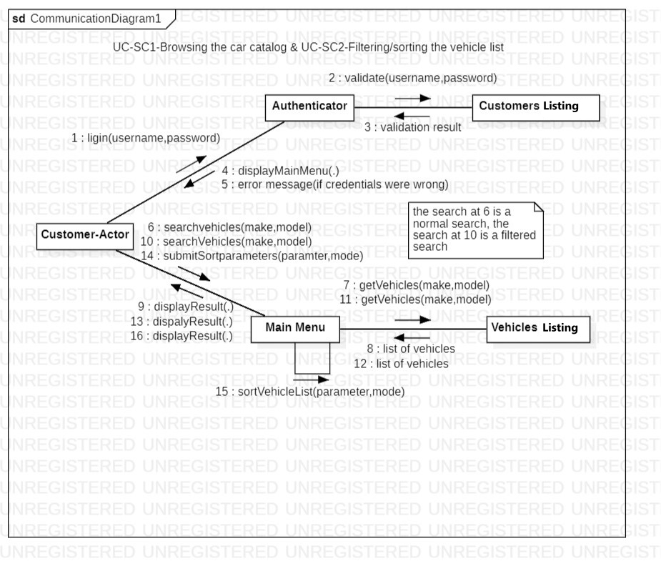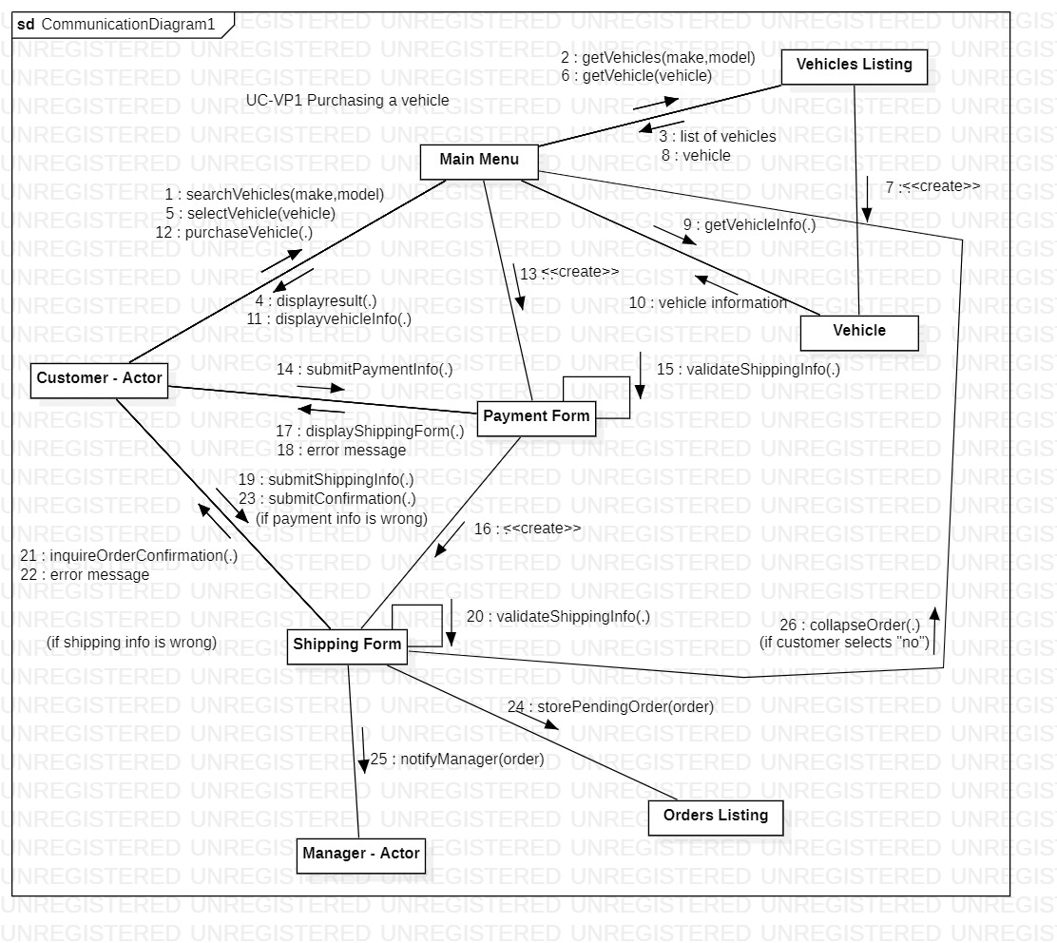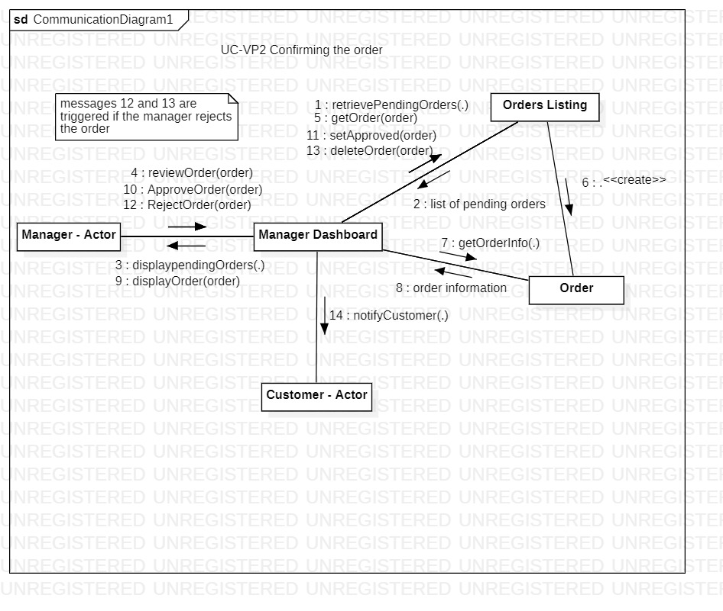

Sequence Diagrams  
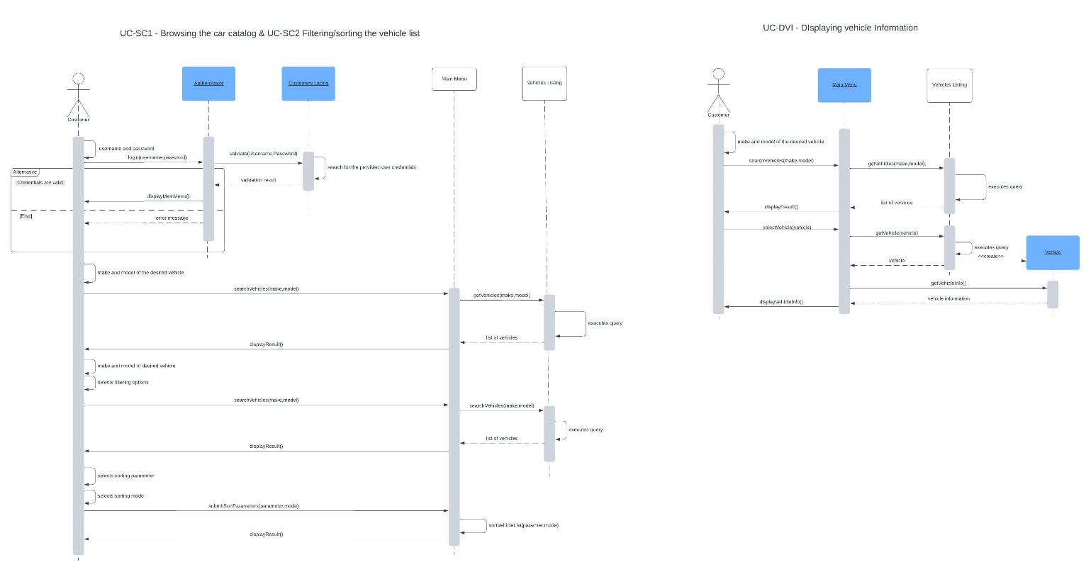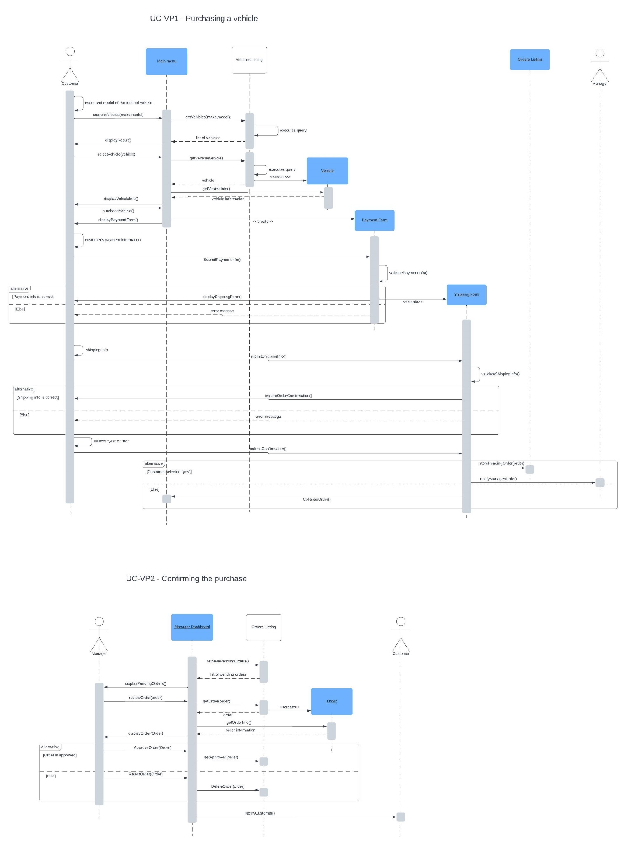

ELISAI MURACI

System Requirements

1-

|  |  |
| --- | --- |
| UC Name | *Real-Time Inventory Management* |
| Summary | Accurate and up-to-date inventory of available cars from manager side |
| Dependency | *This system req. derives from Inventory Tracking System Error Handling and Data Consistency and Efficiency.* |
| Actors | Administrators/Managers |
| Preconditions | For this req. to be set on action the System should have stable Network Infrastructure, Communication channels integrations and Data Consistency. |
| Description of the Main Sequence | 1.Retrieve Inventory Data   * The e-commerce platform initiates the inventory management process by retrieving inventory data from integrated inventory tracking systems or databases. * The platform updates its internal inventory database with the retrieved data, reflecting the current stock levels of different car models and variants. * The platform synchronizes the updated inventory data with the inventory tracking systems to ensure consistency and accuracy across all systems. * Data integrity checks are performed to verify the accuracy and completeness of the synchronized inventory data, ensuring that no discrepancies exist between systems.     2. Inventory Monitoring and Notification:   * The platform continuously monitors stock levels of car models and variants in real-time, tracking changes such as sales, restocks, or backorders. * When a car model or variant goes out of stock, the platform identifies the affected items and triggers an alert/notification mechanism. * Notifications are sent to both suppliers and customers: * Suppliers are informed about out-of-stock items, prompting them to provide restocking information. * Customers are notified about the unavailability of certain items and provided with information on when the items are expected to be back in stock.     3. Supplier Interaction and Replenishment:   * Upon receiving notifications about out-of-stock items, suppliers are notified through predefined communication channels (e.g., email, API). * Suppliers provide restocking information, including expected availability dates, quantities, and delivery schedules for the requested items. * The platform updates inventory status based on the information provided by suppliers, reflecting the expected availability dates and quantities of restocked items. * Customers are notified about the availability of restocked items, enabling them to make informed purchasing decisions or pre-orders/backorders if desired. |

|  |  |
| --- | --- |
| Description of the Alternative  Sequence | 1. Detection of Data Transmission Failure:   * In this sequence, the system detects a failure in data transmission between the e-commerce platform and the inventory tracking system. * The failure could be due to network issues, system downtime, or errors in data synchronization.     2. Fallback Mechanism Activation:   * If the initial attempts to recover from the data transmission failure are unsuccessful, the system activates a fallback mechanism. * The fallback mechanism may involve using cached inventory data, implementing manual inventory updates, or displaying a message to users indicating temporary unavailability of real-time stock information. |
| Non functional requirements | *Network Stability, Data Manipulation Efficiency and Error Handling* |
| Postconditions | *The inventory information displayed to customers accurately reflects the real-time stock levels of cars available for sale.* |

2-

|  |  |
| --- | --- |
| UC Name | *Supplier Communication Integration* |
| Summary | Facilitating communication between the e-commerce  platform and suppliers regarding stock availability and replenishment. |
| Dependency | *Derived from Real-Time Inventory Management.* |
| Actors | Suppliers/Administrators/Managers |
| Preconditions | * Real-Time Inventory Management system is active and accurately tracking inventory. * Stable network infrastructure for reliable communication. * Defined communication channels established between the e-commerce platform and suppliers (e.g., email, API). |
| Description of the Main Sequence | **1. Detection of Inventory Needs:**   * **The system detects inventory needs based on real-time stock levels and customer demand.** * **Identifies items that are out of stock or running low.**     **2. Notification to Suppliers:**   * **Upon detecting inventory needs, the system triggers notifications to suppliers.** * **Notifications include details such as the items needing restocking, quantities required, and urgency.**     **3. Supplier Response:**   * **Suppliers receive notifications through predefined communication channels (e.g., email, API).** * **Suppliers provide information on restocking availability, quantities, and delivery schedules.**     **4. Inventory Update:**   * **The system updates inventory status based on information provided by suppliers.** * **Reflects expected availability dates, quantities, and delivery schedules for restocked items.** |
| Description of the Alternative  Sequence | *1. Failure in Supplier Communication:*   * *If there's a failure in communicating with suppliers (e.g., network issues):* * *The system activates error handling procedures to address the communication failure.* * *Attempts to resend notifications or use alternative communication channels.* |
| Nonfunctional requirements | * *Communication Reliability: Ensure reliable communication channels with suppliers.* * *Timeliness: Ensure timely communication to minimize stockouts and delays.* * *Data Security: Ensure secure transmission of sensitive inventory information.* |

|  |  |
| --- | --- |
| Postconditions | *Suppliers are informed about inventory needs accurately and promptly, facilitating timely replenishment and ensuring optimal stock levels for customers.* |

3-

|  |  |
| --- | --- |
| UC Name | *Customer Notification System* |
| Summary | Informing customers about stock availability status. |
| Dependency | *Derived from Real-Time Inventory Management.* |
| Actors | Customers, System. |
| Preconditions | * Real-Time Inventory Management system is active and accurately tracking inventory. * Stable network infrastructure for reliable communication. * Defined notification mechanisms such as email or SMS. |
| Description of the Main Sequence | **1. Monitoring Inventory Changes:**   * **The system continuously monitors stock levels in real-time.** * **Detects changes such as items going out of stock or being restocked.**     **2. Customer Notification:**   * **When an item goes out of stock, the system triggers a notification process.** * **Sends notifications to customers via predefined channels (e.g., email, SMS).** * **Notifications include information on the unavailability of items and expected restock dates.**     **3. Providing Information for Informed Decisions:**   * **Customers receive notifications promptly, enabling them to make informed purchasing decisions.** * **Options for pre-orders or back-orders are provided if available.** |
| Description of the Alternative  Sequence | *1. Failure in Notification Transmission:*   * *If there's a failure in transmitting notifications (e.g., network issues):* * *The system activates error handling procedures to address the transmission failure.* * *Attempts to resend notifications or use alternative communication channels.* |
| Nonfunctional requirements | *Non-functional Requirements:*   * *Notification Delivery Speed: Ensure notifications are delivered promptly.* * *Notification Accuracy: Ensure notifications contain accurate information.* * *Notification Channel Reliability: Ensure reliability of communication channels.* |
| Postconditions | *Customers are informed about stock availability status accurately and promptly, facilitating informed purchasing decisions.* |

4-

|  |  |
| --- | --- |
| UC Name | *Customer Relationship Management (CRM)* |
| Summary | Managing interactions with customers to enhance their experience, provide personalized assistance, and foster long-term relationships. |
| Dependency | *Derived from Real-Time Inventory Management.* |
| Actors | Customers/Sales Representatives |
| Preconditions | * Real-Time Inventory Management system is active and accurately tracking inventory. - Centralized database of customer information, including contact details, purchase history, and preferences. * Defined communication channels established between the system and customers (e.g., email, live chat). |
| Description of the Main Sequence | **1. Customer Data Management:**   * **The system maintains a centralized database of customer information, including contact details, purchase history, and preferences.** * **Updates customer records with new interactions, purchases, or preferences.**     **2. Customer Interaction:**   * **Customers interact with the system through various touchpoints such as the website, mobile app, or customer service channels.** * **The system provides personalized assistance based on customer data and preferences.** * **Sales representatives utilize customer profiles to offer tailored recommendations and assistance during the sales process.**     **3. Customer Segmentation:**   * **The system segments customers based on various criteria such as demographics, purchase behavior, or engagement level.** * **Segmentation enables targeted marketing campaigns, promotions, and communication strategies.**     **4. Loyalty Programs:**   * **The system manages loyalty programs to reward repeat customers and encourage brand loyalty.** * **Tracks customer loyalty points, rewards, and redemption activities.**     **5. Follow-Up Communication:**   * **The system initiates follow-up communication with customers to gather feedback, address concerns, or offer post-purchase support.** * **Utilizes communication channels such as email, SMS, or phone calls to stay engaged with customers.** |
| Description of the Alternative  Sequence | *1. Customer Data Inconsistency:*   * *If inconsistencies are detected in customer data:* * *The system triggers data validation processes to reconcile discrepancies and ensure data accuracy.* * *Notifies administrators or managers to investigate and resolve data inconsistencies.* |

|  |  |
| --- | --- |
| Nonfunctional requirements | * *Data Security: Ensure the security and confidentiality of customer data.* * *Personalization: Provide personalized experiences tailored to individual customer preferences.* * *Responsiveness: Ensure timely responses to customer inquiries and requests.* |
| Postconditions | *Customer satisfaction is enhanced through personalized assistance, targeted communication, and effective resolution of inquiries or concerns, fostering long-term relationships and repeat business.* |

5-

|  |  |
| --- | --- |
| UC Name | *Inventory Forecasting and Replenishment* |
| Summary | Predicting future demand for car models and variants based on historical data and initiating replenishment orders to maintain optimal inventory levels. |
| Dependency | *Derived from Real-Time Inventory Management.* |
| Actors | Administrators/Managers |
| Preconditions | * Real-Time Inventory Management system is active and accurately tracking inventory. * Availability of historical sales data and inventory records. * Stable network infrastructure for data retrieval and communication with suppliers. |
| Description of the Main Sequence | **1. Data Analysis and Forecasting:**   * **The system analyzes historical sales data, customer trends, and market demand.** * **Utilizes statistical methods or machine learning algorithms to forecast future demand for car models and variants.**     **2. Replenishment Planning:**   * **Based on demand forecasts, the system generates replenishment plans to restock inventory.** * **Considers factors such as lead times from suppliers, storage capacity, and budget constraints.**     **3. Replenishment Order Generation:**   * **The system automatically generates replenishment orders for items that are forecasted to be in high demand or are running low in stock.** * **Orders include details such as quantities, preferred suppliers, and delivery schedules.**     **4. Supplier Interaction:**   * **Replenishment orders are sent to suppliers through predefined communication channels (e.g., email, API).** * **Suppliers acknowledge receipt of orders and provide confirmation of expected delivery dates.**     **5. Inventory Update:**   * **Upon confirmation from suppliers, the system updates inventory status to reflect expected arrival dates and quantities of restocked items.** * **Adjusts stock levels accordingly to maintain optimal inventory levels.** |
| Description of the Alternative  Sequence | *1. Inaccurate Forecasting:*   * *If demand forecasting results in inaccuracies:* * *The system triggers a review process to analyze the reasons for discrepancies.* * *Adjusts forecasting models or parameters based on new data or insights.* |
| Nonfunctional requirements | * *Forecasting Accuracy: Ensure accurate prediction of demand to prevent overstocking or stockouts.* * *Replenishment Efficiency: Ensure timely generation and processing of replenishment orders.* |

|  |  |
| --- | --- |
|  | *- Scalability: Ensure the system can handle large volumes of data for accurate forecasting and efficient replenishment.* |
| Postconditions | *Optimal inventory levels are maintained, ensuring availability of car models and variants to meet customer demand while minimizing excess inventory costs.* |

ELISAI MURACI

*ACTIVITY DIAGRAMS*

1-

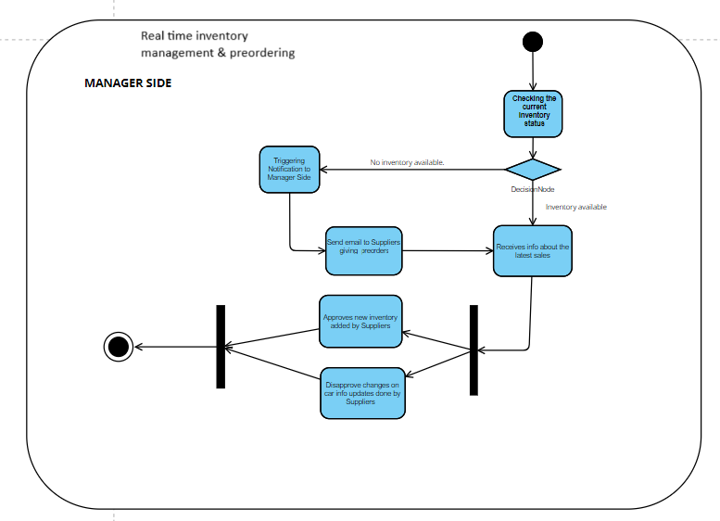

2-

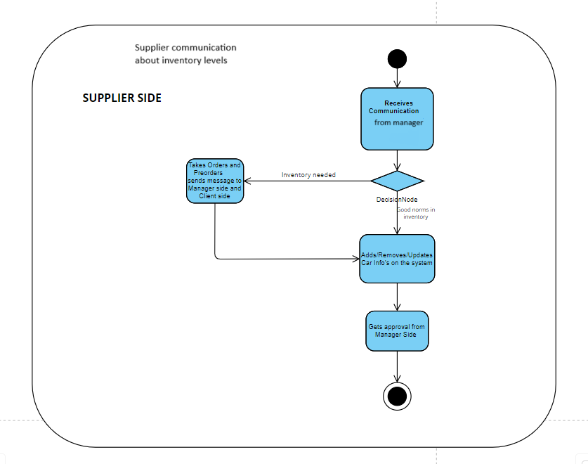

3-

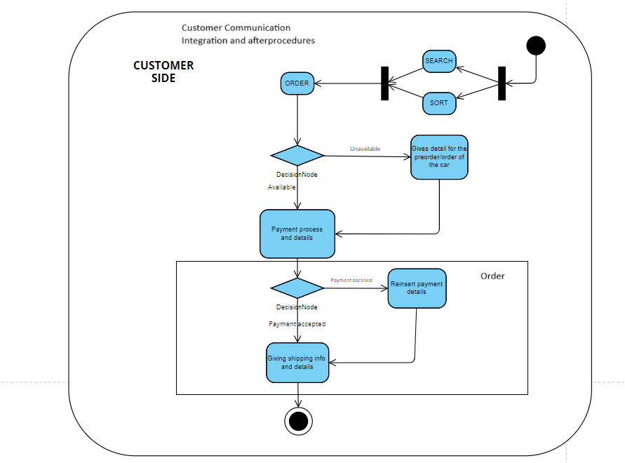

4-

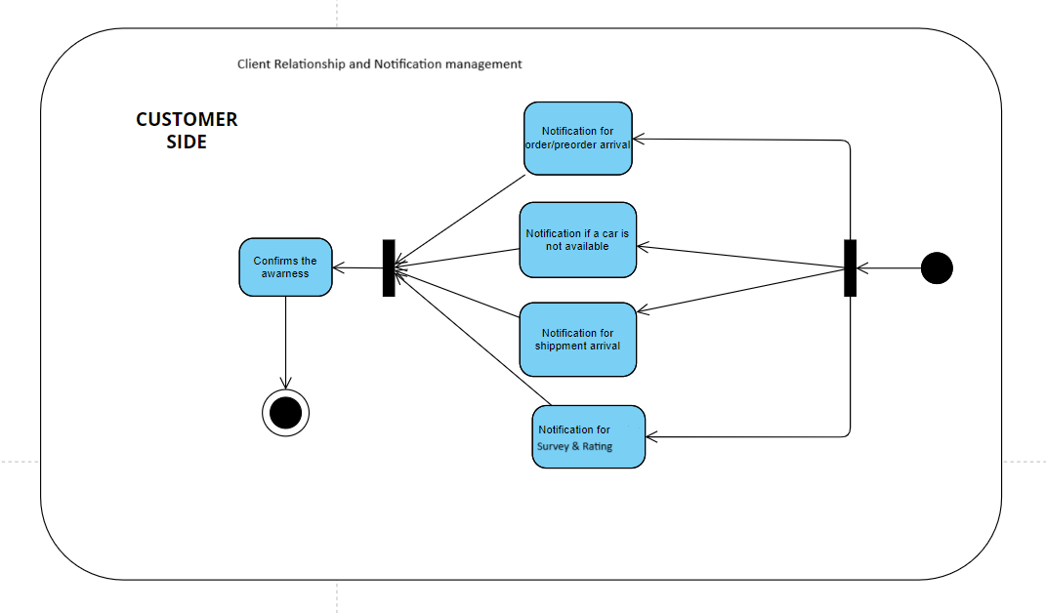

5-

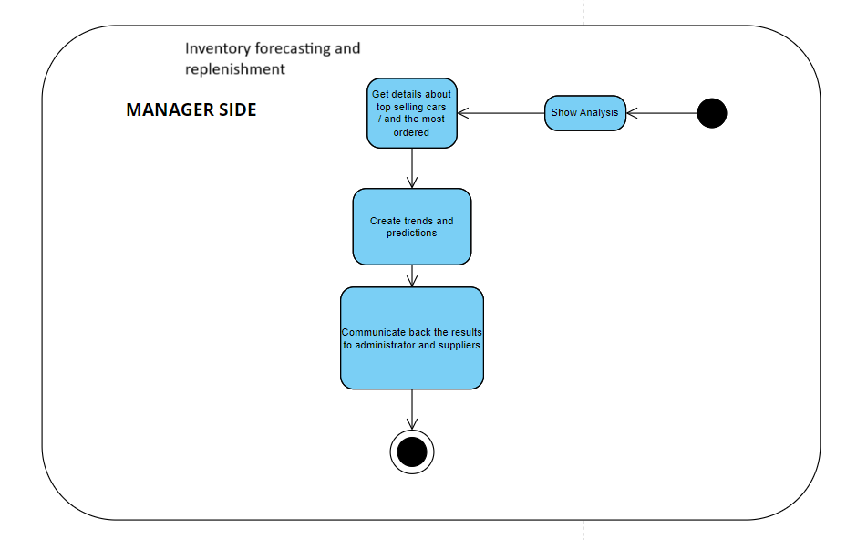

ELISAI MURACI

*SEQUENTIAL DIAGRAMS & COLLABORATIVE DIAGRAMS*

*1-*

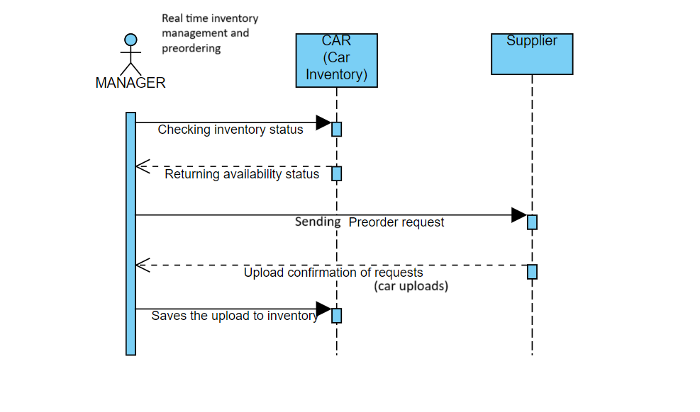

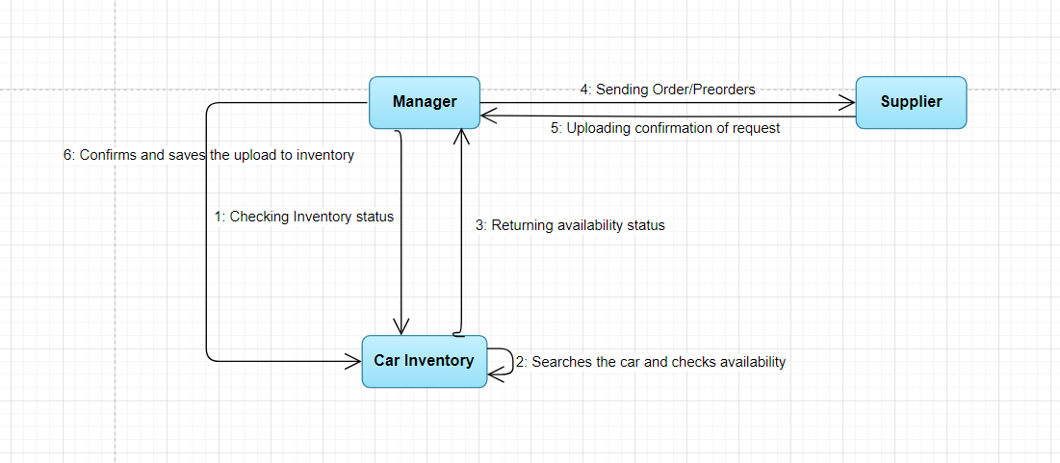

2-

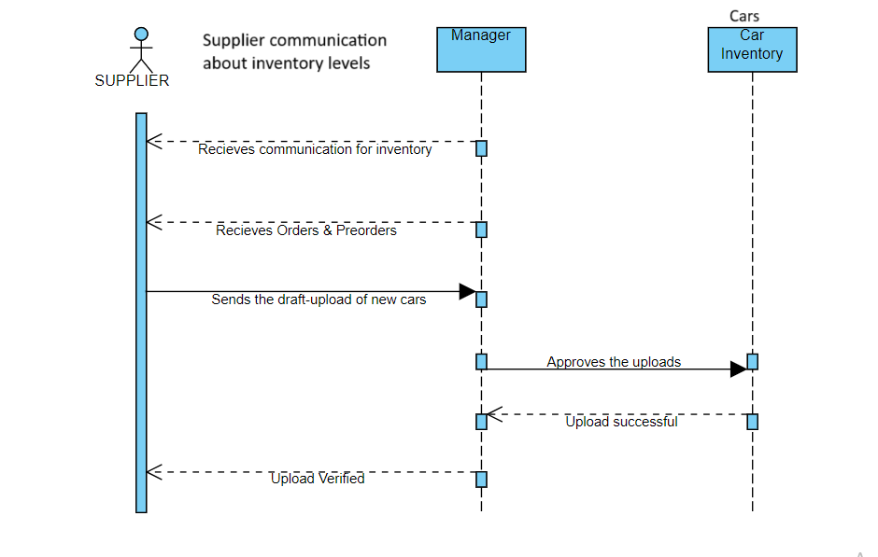

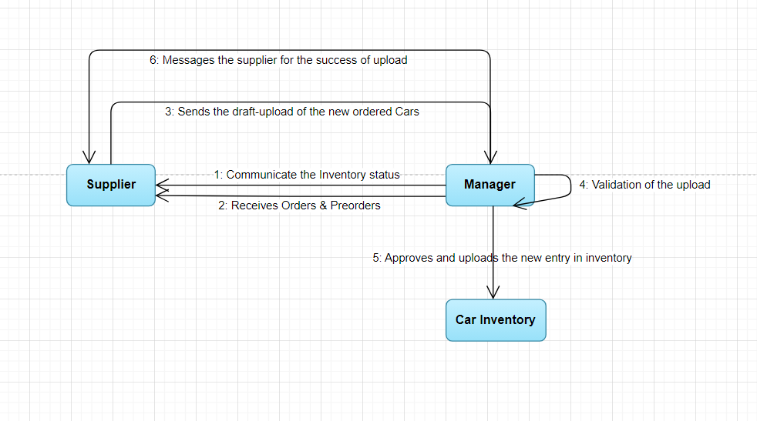

3-

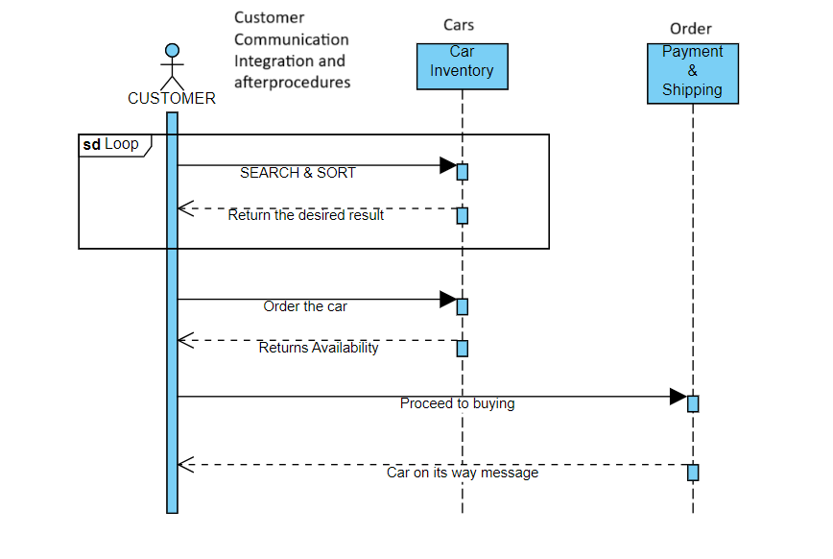

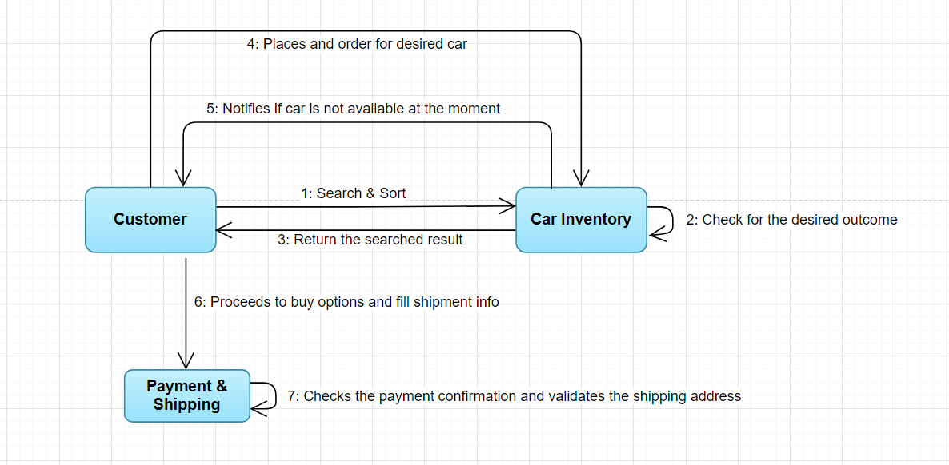

4-

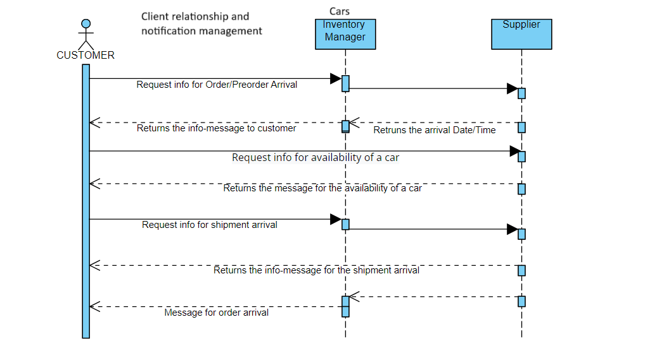

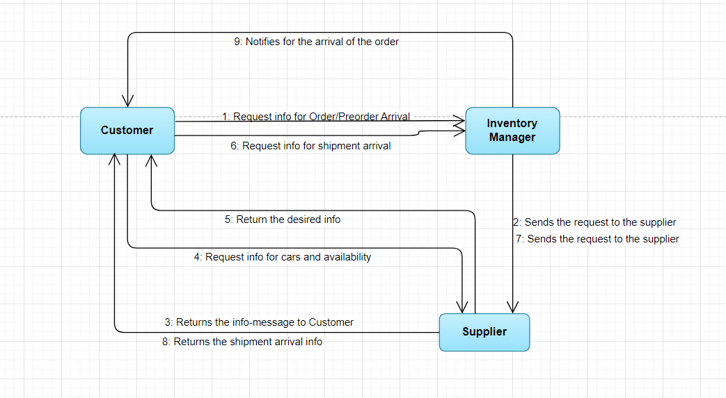

5-

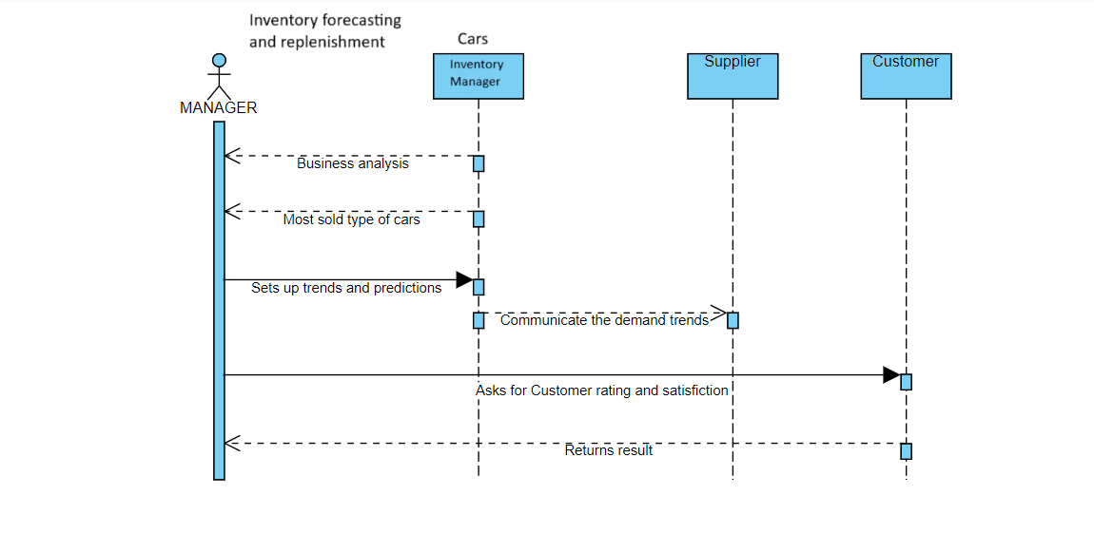

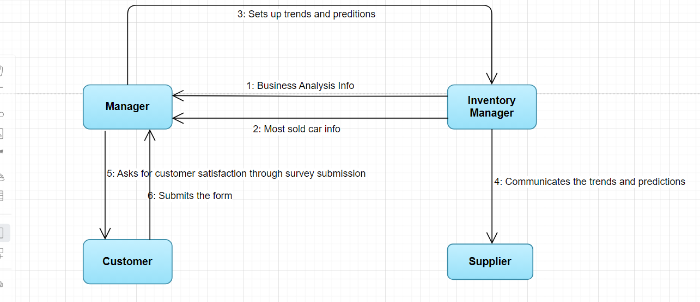

IRIDA LALA

System Requirements

|  |  |
| --- | --- |
| UC Name | *Dashboard Including Visual Display* |
| Summary | *Provide managers with access to a specialized dashboard displaying graphical representations of key performance indicators such as total sales and top-selling automobiles on a monthly basis.* |
| Dependency | *None* |
| Actors | *Primary Actor: Manager*  *Secondary Actors: None* |
| Preconditions | |  | | --- | | *The manager is logged into the car selling system.* | |  | |
| Description of the Main Sequence | * *The manager navigates to the dashboard section of the car selling system* * *The system retrieves monthly performance data from the database* * *The system generates graphical representations (e.g., charts, graphs) of key performance indicators such as total sales and top-selling automobiles* * *: The system displays the graphical representations on the dashboard* |
| Description of the Alternative Sequence | * *n/a* |
| Non functional requirements | *The dashboard must load within 5 seconds of the manager's request*  *Graphical representations must be interactive, allowing managers to hover over data points for more information*  *The dashboard should be visually appealing and intuitive to navigate, enhancing user experience.* |
| Postconditions | *The manager has successfully viewed the dashboard displaying monthly performance indicators.* |

|  |  |
| --- | --- |
| UC Name | *Mobile Compatibility* |
| Summary | *Ensure that the system is compatible with mobile devices, allowing managers to view monthly insights using smartphones or tablets.* |
| Dependency | *None* |
| Actors | *Primary Actor: Manager*  *Secondary Actors: None* |
| Preconditions | |  | | --- | | *The manager is using a mobile device (smartphone or tablet).* | |  | |
| Description of the Main Sequence | * *The manager opens the web browser on their mobile device* * *The manager navigates to the login page of the car selling system* * *: The manager enters their username and password* * *The system verifies the credentials and grants access* * *The manager navigates to the analytics page* * *The system displays the monthly insights in a mobile-friendly format, adjusting the layout for smaller screens* |
| Description of the Alternative Sequence | * *n/a* |
| Non functional requirements | *The system's web interface must adapt responsively to different screen sizes and orientations to ensure usability on various mobile devices*  *Mobile access must provide comparable performance and functionality to desktop access*  *The system should support common mobile browsers such as Safari (iOS) and Chrome (Android) to ensure compatibility across different platforms.* |
| Postconditions | *The manager has successfully viewed monthly insights on their mobile device* |

|  |  |
| --- | --- |
| UC Name | *Real-Time Data Updates:* |
| Summary | *Provide managers with real-time updates to the monthly analytics, ensuring access to the most recent data for decision-making and performance evaluation..* |
| Dependency | *None* |
| Actors | *Primary Actor: Manager*  *Secondary Actors: None* |
| Preconditions | |  | | --- | | *The manager is logged into the car selling system.* | |  | |
| Description of the Main Sequence | * *The manager navigates to the monthly analytics section of the car selling system* * *The system retrieves the latest data from the database* * *The system updates the monthly analytics with the most recent data* * *The system displays the updated analytics to the manager* |
| Description of the Alternative Sequence | * *n/a* |
| Non functional requirements | *Updates should occur automatically without requiring manual intervention from the manager*  *the system should be capable of handling high volumes of data and processing updates*  *The system must update the monthly analytics in real-time as new data becomes available.* |
| Postconditions | *The manager has successfully viewed the monthly analytics with real-time data updates* |

|  |  |
| --- | --- |
| UC Name | *Filtering and Sorting Options* |
| Summary | *Provide managers with filtering and sorting options on the dashboard to narrow down displayed data based on parameters such as time range, vehicle category, geographic region, or salesperson.* |
| Dependency | *None* |
| Actors | *Primary Actor: Manager*  *Secondary Actors: None* |
| Preconditions | |  | | --- | | *The manager is logged into the car selling system and is on the dashboard page.* | |  | |
| Description of the Main Sequence | * *The manager selects the desired filtering option from the available parameters* * *The system retrieves data based on the selected filtering option* * *The system updates the dashboard to display the filtered data* * *The manager reviews the updated dashboard* |
| Description of the Alternative Sequence | * *n/a* |
| Non functional requirements | *The dashboard must provide a user-friendly interface for selecting and applying filtering options*  *Filtering and sorting operations should be performed quickly*  *The system should support concurrent filtering options, allowing managers to apply multiple filters simultaneously* |
| Postconditions | *The manager has successfully filtered and viewed the dashboard based on the selected parameters.* |

|  |  |
| --- | --- |
| UC Name | *Access Control and Security* |
| Summary | *Ensure that access to the analytics page is restricted to authorized personnel (managers) and implement authentication mechanisms* |
| Dependency | *None* |
| Actors | *Primary Actor: Manager*  *Secondary Actors: None* |
| Preconditions | |  | | --- | | *The manager is attempting to access the analytics page.* | |  | |
| Description of the Main Sequence | * *The manager navigates to the analytics page.* * *The system prompts the manager to enter their username and password.* * *The manager enters their credentials.* * *The system verifies the entered credentials against the authorized user database.* * *If the credentials are valid, the system grants access to the analytics page.* * *the system may prompt the manager to complete multi-factor authentication (e.g., via SMS code or authenticator app)* * *The manager successfully accesses the analytics page.* |
| Description of the Alternative Sequence | * *n/a* |
| Non functional requirements | *The system must authenticate managers within 3 seconds.*  *Multi-factor authentication must be completed within 1 minute of the initial login attempt.*  *ccess to the analytics page must be encrypted using industry-standard protocols (e.g., HTTPS) to ensure data security during transmission.* |
| Postconditions | *The manager has successfully accessed the analytics page after authentication.* |

IRIDA LALA

Activity Diagrams

**the managers have access to monthly analytics to track key measures such as total sales,top selling vehicles etc.**

**(these are views only on the backend, just a page with graphs nothing else )**

**1.Access Control and Security**:

The access to the analytics page shall be only accessed to authorized personnel (the managers). Access control and strong authentication mechanisms such as username/password and multi-factor authentication should be implemented.

**2.Mobile Compatibility**

To ensure flexibility and ease in performance monitoring, the system should be compatible with mobile devices. This would enable managers to view monthly insights using smartphones or tablets while they are on the go.

**3.Dashboard including Visual Display**

Managers should have access to a specialized dashboard that shows graphical representations of important performance indicators, including total sales, top-selling automobiles, and other data, on a monthly basis.

**4.Real-Time Data Updates**

To ensure that managers have access to the most recent data and can make decisions and evaluate performance on time, the system should offer real-time updates to the monthly analytics.

**5.Filtering and Sorting Options**

To help managers concentrate on particular performance metrics, the dashboard should have filtering and sorting options that let them narrow down the data displayed based on parameters like time range (monthly, quarterly, annual), vehicle category, geographic region, or salesperson.

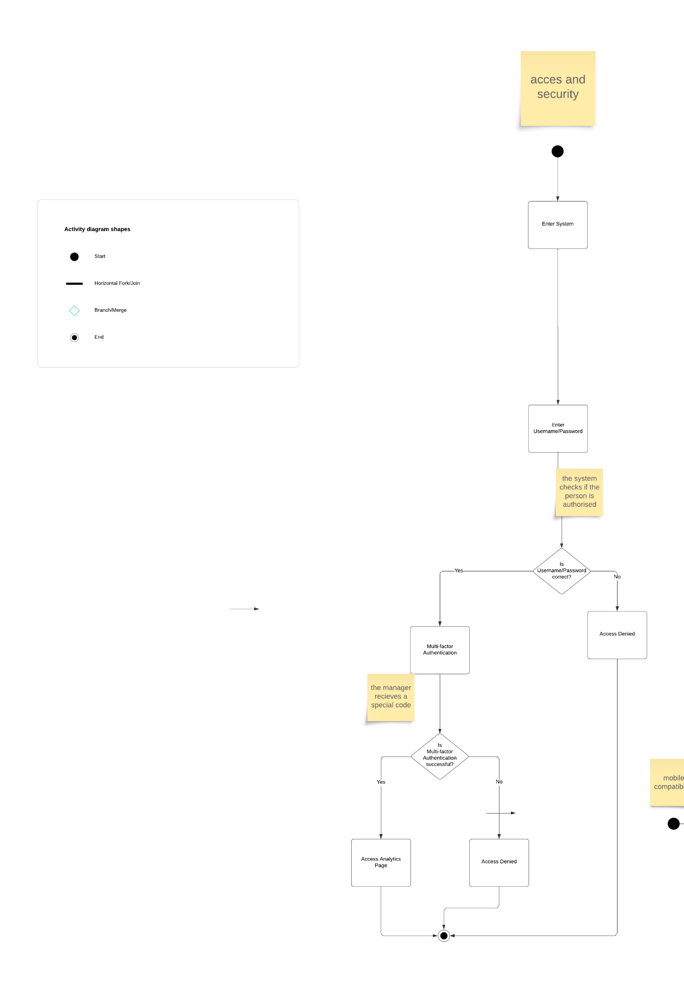

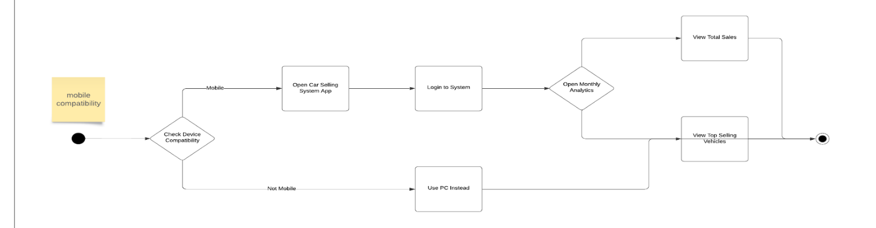

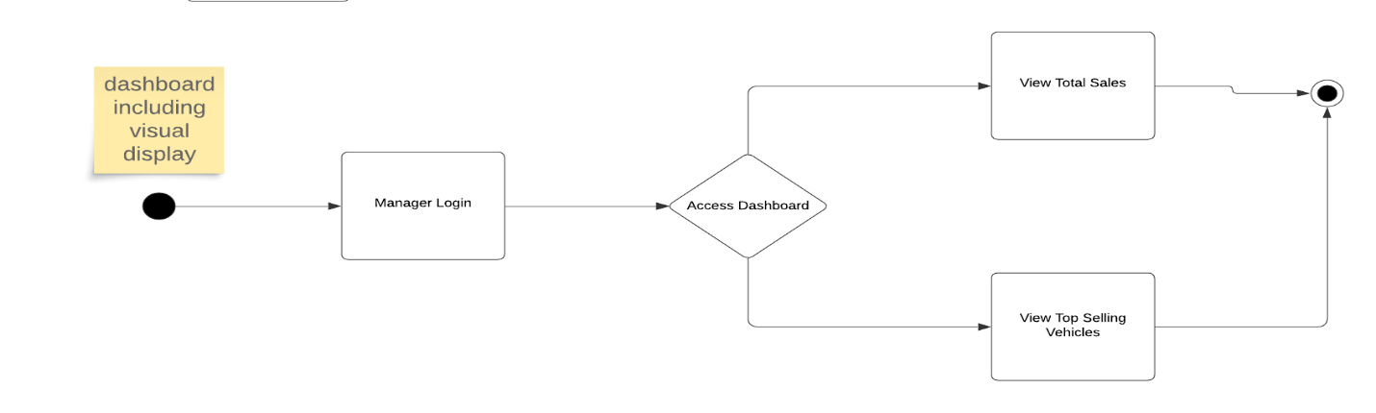

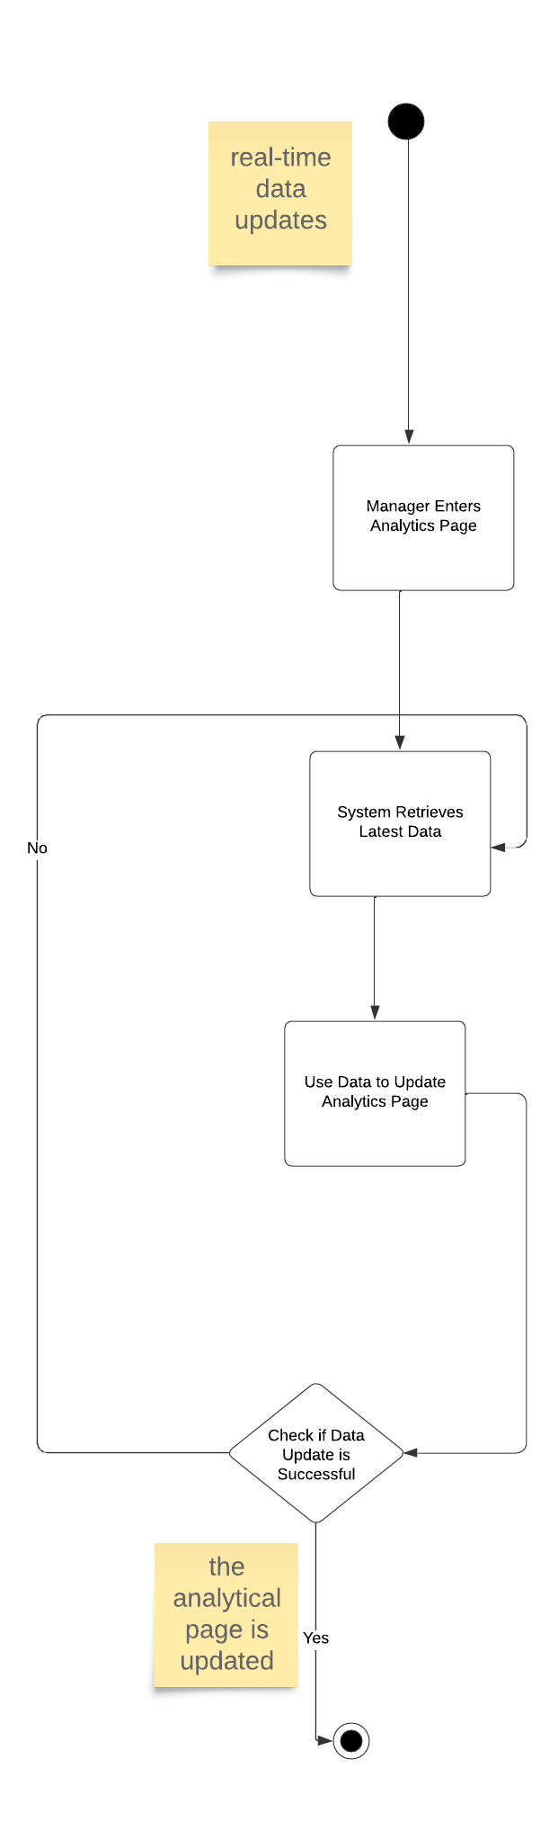

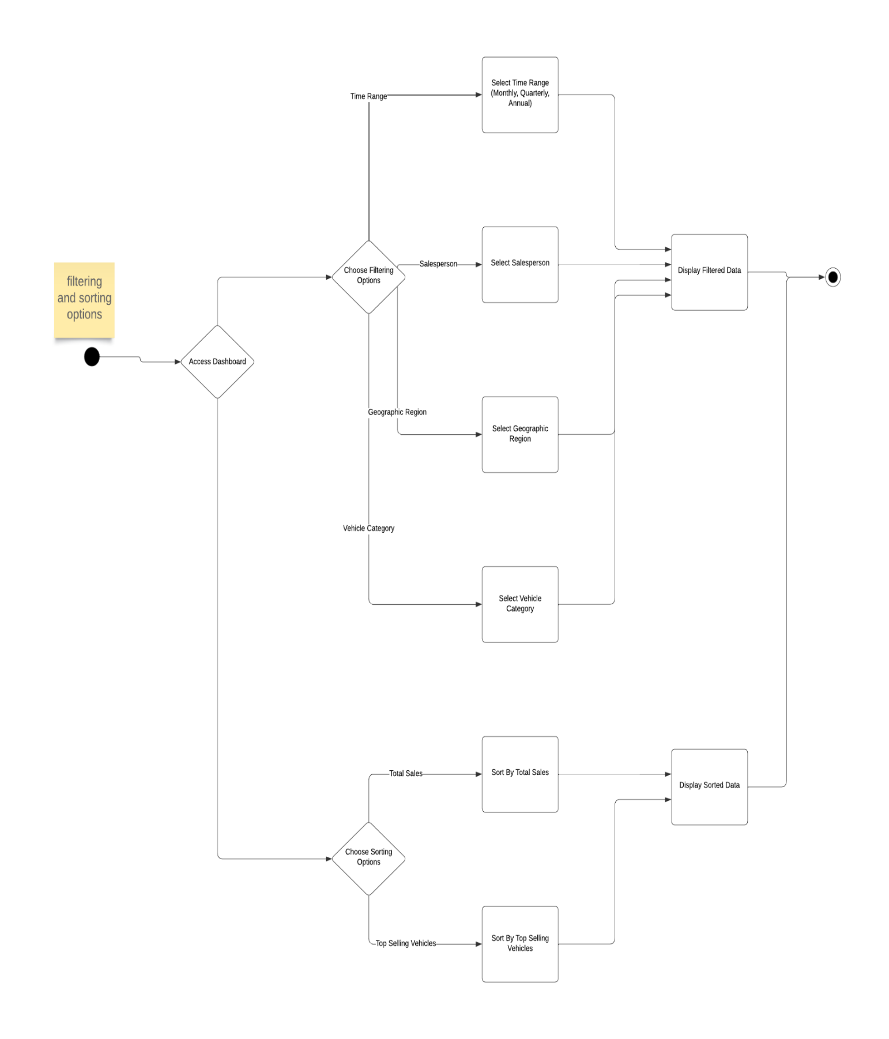

IRIDA LALA

Sequence & Collaboration Diagrams

COMMUNICATION DIAGRAMS

Access Control and Security

1. Login

2. Verification of username/password

3. Multi-factor request

4. MFA code

5. Analytics access

6. Analytics are displayed

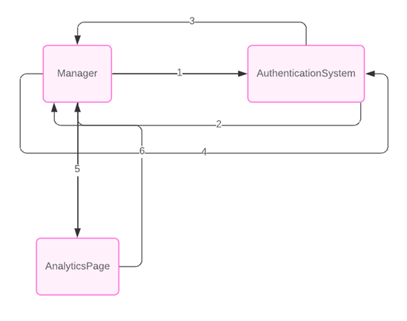

Filtering and Sorting Options

1. Request the options

2. Retrieve filter options

3. Send filter options

4. Retrieve sorting options

5. Send sorting options

6. Display all options

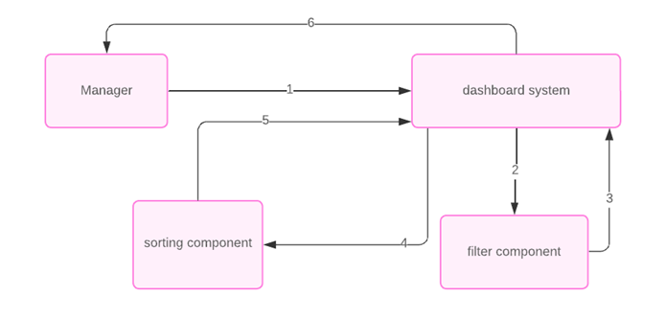

SEQUENCE DIAGRAMS

• ACCESS AND SECURITY

1. The manager initiates a request to view the analytics page.

2. The analytics page sends a request to the authentication server to authenticate the manager.

3. The authentication server prompts the manager for their username and password.

4. The manager submits their username and password to the authentication server.

5. The authentication server verifies the submitted credentials.

6. If required, the authentication server prompts the manager for multi-factor authentication.

7. The manager confirms the multi-factor authentication.

8. The authentication server verifies the multi-factor authentication.

9. Once authentication and authorization are successful, the authentication server notifies the analytics page.

10. The analytics page grants access to the manager and displays the analytics.

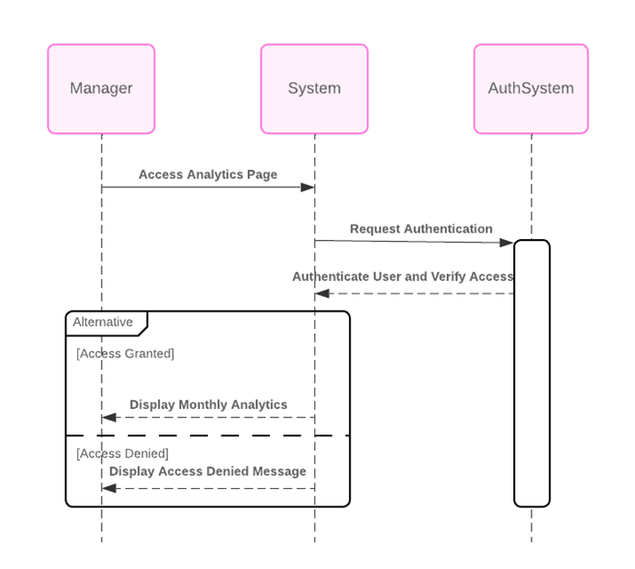

• Filtering and Sorting Options

1. he manager initiates a request to view the dashboard with filtering and sorting options.

2. The dashboard system sends a request to the backend system to retrieve the monthly analytics data.

3. The backend system responds by sending the monthly analytics data to the dashboard system.

4. The dashboard system applies the specified filtering and sorting options to the received data.

5. Finally, the dashboard system sends the dashboard with filtered and sorted data back to the manager for viewing

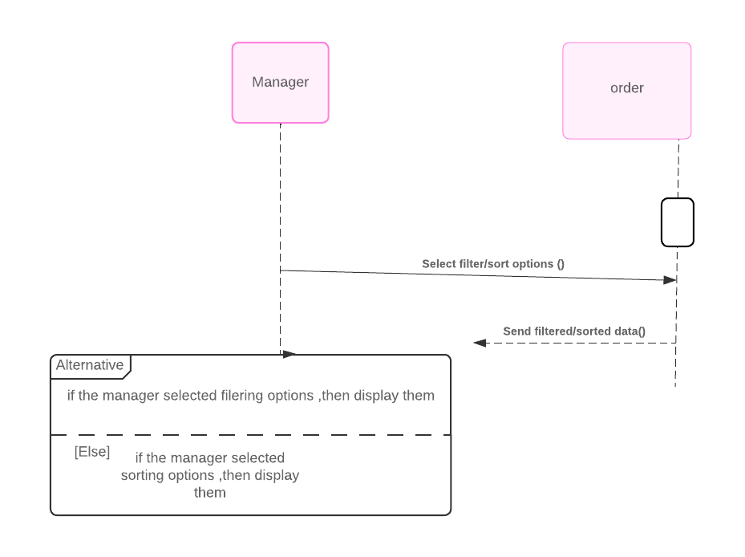

Olsi Llavanji

System Requirements

|  |  |
| --- | --- |
| UC Name | *Ad Management* |
| Summary | *This use case enables the marketing team to create and manage ads within the car selling platform, promoting deals and showing the listings to the right people.* |
| Dependency |  |
| Actors | *Primary Actor: Marketing Team Member*  *Secondary Actors: System Administrator* |
| Preconditions | *The actor must be logged in with marketing team credentials.*  *The actor has been granted permissions to access the Ad Management Module.* |
| Description of the Main Sequence | *1. Creating the Ad:*   * *The marketing team member selects the option to create a new ad.* * *The member fills in ad details, such as the way the ad will be shown, using a banner, a featured listing, etc. The content it will hold (images, videos, text), and the target audience.* * *The system validates the input and saves the ad.*   *2. Ad Scheduling:*   * *The member chooses the start and end dates for the ad to be shown.* * *The system checks for scheduling conflicts with other ads, if everything is right, it confirms it.*   *3. Ad Publishing:*   * *The member reviews the ad preview and submits it to be published.* * *The system loads the ad and sets it to be published to the right audience within the start and end dates set by the user.* |
| Description of the Alternative Sequence | *1. Ad Modification:*  *• Before the ad is published the marketing team can edit it to their liking.*  *• The system allows these modifications and updates the ad ad.*  *2. Ad Cancellation:*  *• The ad can be cancelled by the marketing team before it goes live.*  *• The system deletes the ad and confirms deletion and cancellation to the member.* |
| Non functional requirements | *• Performance: The system should load the Ad Management Module in 2 seconds for a smooth user experience.*  *• Usability: The interface should be minimal and easy to use in order for the marketing team not to spend too much time on training.*  *• Security: Only authorized users can interact with the ads. All interactions will be logged and stored.*  *• Scalability: The system should be able to handle many ads without performance issues.* |
| Postconditions | *• If an ad gets published successfully, it will be shown excactly like in the preview and withing the scheduled dates.*  *• The marketing team member can view and manage the ad through the Ad Management Module.*  *• Data related to the ad’s performance are collected and shown to the team for review.* |

|  |  |
| --- | --- |
| UC Name | *Dynamic Content Personalization* |
| Summary | *This use case involves providing dynamic content personalization capabilities to the marketing team, allowing them to customize ads and promotions based on user behavior, preferences, and past interactions with the site. It includes personalizing car recommendations and promotional offers.* |
| Dependency | *This optional section describes whether the UC depends on other UCs.* |
| Actors | *-Marketing Team: Initiates the personalization of ads and promotions based on user data.*  *-System: Executes the dynamic content personalization process.* |
| Preconditions | *-The marketing team member must have access permissions.*  *-Sufficient user data, like behavior, preferences, and past interactions, must be available in the system.* |
| Description of the Main Sequence | *-The marketing team member logs into the system.*  *-The marketing team member navigates to the dynamic content personalization section.*  *-The marketing team member selects the type of content to personalize (e.g., car recommendations, promotional offers).*  *-The system retrieves user data, such as behavior, preferences, and past interactions.*  *-The marketing team member defines personalized criteria and rules for the selected content type (e.g., users who viewed SUVs in the past week, users who have clicked on previous promotional offers).*  *-The system applies the personalized criteria generates personalized content options.*  *-The marketing team member reviews and approves the personalized content options.*  *-The system deploys the personalized content to the appropriate channels (e.g., website, social media, email campaigns).* |
| Description of the Alternative Sequence | *-If insufficient user data is available for personalization, the system notifies the user, and the user may choose to proceed with generic content or refine the personalization criteria.*  *-If the generated personalized content options do not meet the marketing team's expectations, the marketing team member can adjust the criteria and rules for better results.* |
| Non functional requirements | *-The system should process and apply personalization rules in real-time or near-real-time to ensure fast delivery of personalized content.*  *-The system should continuously update user data and adapt personalization strategies based on user behavior and preferences.* |
| Postconditions | *-The marketing team successfully deploys personalized content to user behavior, preferences, and past interactions.*  *-The system logs the personalization process and outcomes for analysis.* |

|  |  |
| --- | --- |
| UC Name | *Generate Marketing Analytics Report* |
| Summary | *This use case involves generating detailed analytics and reporting tools for the marketing team to monitor the performance of ads and promotions. It allows tracking metrics such as click rates, impressions, conversion rates, exporting reports in multiple formats.* |
| Dependency | *This optional section describes whether the UC depends on other UCs.* |
| Actors | *-Marketing Team: Requests generation of analytics reports.*  *-System: Executes the generation and export of analytics reports.* |
| Preconditions | *-The marketing team member must have access permissions.*  *-Sufficient data on ad performance must be available in the system.* |
| Description of the Main Sequence | *-The marketing team member logs into the system.*  *-The marketing team member navigates to the analytics and reporting section.*  *-The marketing team member selects the parameters for the report (e.g., date range, specific ad/promotion).*  *-The system retrieves the data based on the selected parameters.*  *-The system generates the analytics report.*  *-The marketing team member selects the export format (e.g., PDF, Excel).*  *-The system exports the report in the chosen format.*  *-The marketing team member receives the exported report.* |
| Description of the Alternative Sequence | *-If the selected parameters for the report has insufficient data, the system notifies the user, and the user adjusts the parameters.*  *-If the export format selected is not supported, the system notifies the user and makes them choose a supported format.* |
| Non functional requirements | *-The system should generate reports within seconds.*  *-The exported reports should be accurate and contain all relevant metrics.*  *-The system should support multiple requests from multiple users without performance issues.* |
| Postconditions | *-The marketing team member receives the report in the selected format.*  *-The system logs the generation and export of the report.* |

|  |  |
| --- | --- |
| UC Name | *User Feedback and Interaction Tracking* |
| Summary | *This use case involves providing tools within the system for collecting and analyzing user feedback on ads and promotions. It includes mechanisms for users to rate ads, report issues, or provide direct feedback.* |
| Dependency | *This optional section describes whether the UC depends on other UCs.* |
| Actors | *-Users: Provide feedback and interact with ads and promotions.*  *-Marketing Team: Access and analyze user feedback.* |
| Preconditions | *-Ads and promotions must be actively running within the system.*  *-Users must have access to the ads and promotions to provide feedback.* |
| Description of the Main Sequence | *-Users encounter an ad or promotion within the system.*  *-The system provides mechanisms for users to provide feedback.*  *-Users interact with the ad or promotion by clicking on it or viewing its content.*  *-The system tracks user interactions, including clicks, views, and time spent, and associates them with the respective ad.*  *-The marketing team accesses the collected feedback and interaction data within the system.*  *-The marketing team analyzes the feedback to identify areas for improvement.*  *-Based on the analysis, the marketing team optimizes future campaigns.* |
| Description of the Alternative Sequence | *-If a user encounters technical issues while providing feedback or interacting with an ad, the system provides alternative methods for submitting feedback.*  *-If the system encounters errors in tracking user interactions, it logs the issue for troubleshooting and notifies the marketing team.* |
| Non functional requirements | *-The system should provide user-friendly mechanisms for submitting feedback.*  *-Feedback submission and interaction tracking processes should be reliable and efficient.*  *-The system should protect user privacy and handle feedback data securely.* |
| Postconditions | *-User feedback and interaction data are successfully collected and stored within the system.*  *-The marketing team utilizes the collected data to optimize future campaigns.*  *-Any reported issues or concerns raised by users are addressed by the marketing team based on the feedback received.* |

OLSI LLAVANJI

Activity Diagram

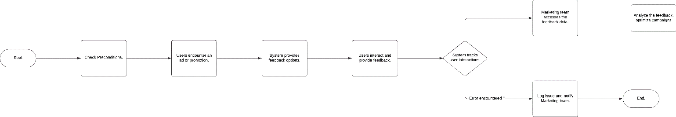  
  
  
  
  
  
  
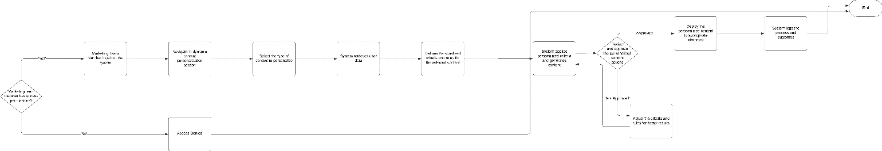  
  
  
  
  
  
  
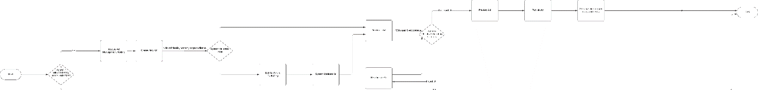

OLSI LLAVANJI

Sequence & Collaboration Diagram

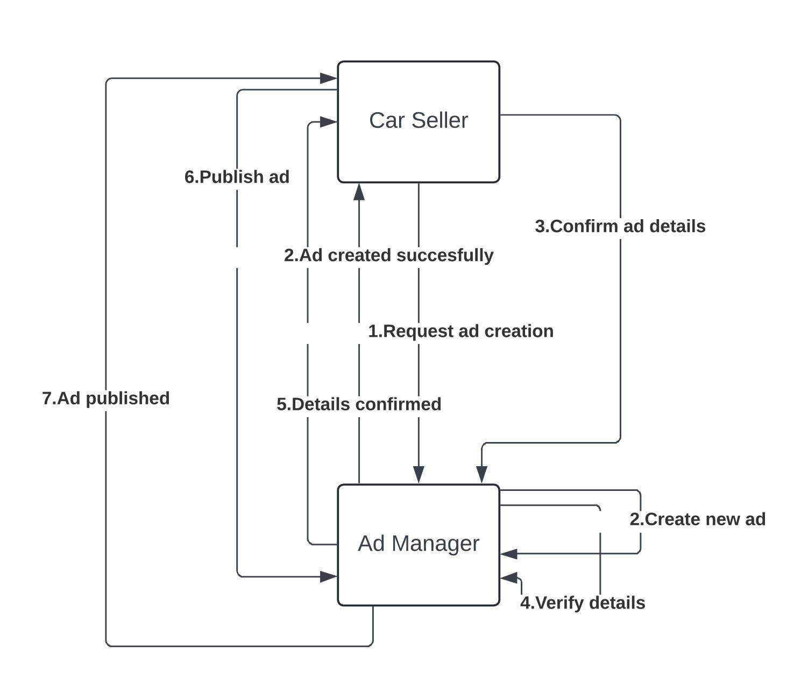

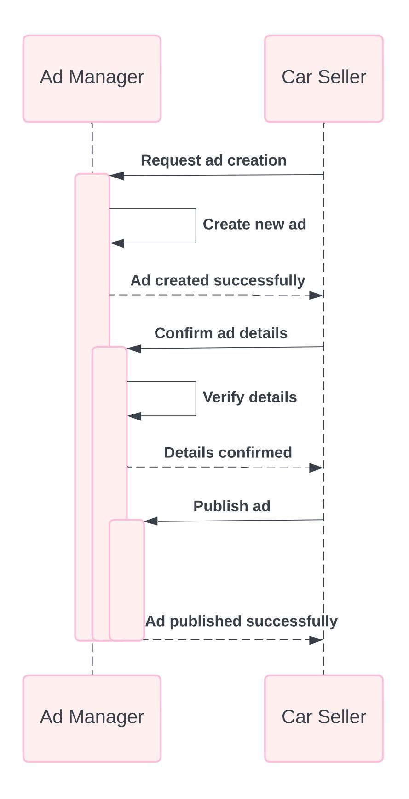

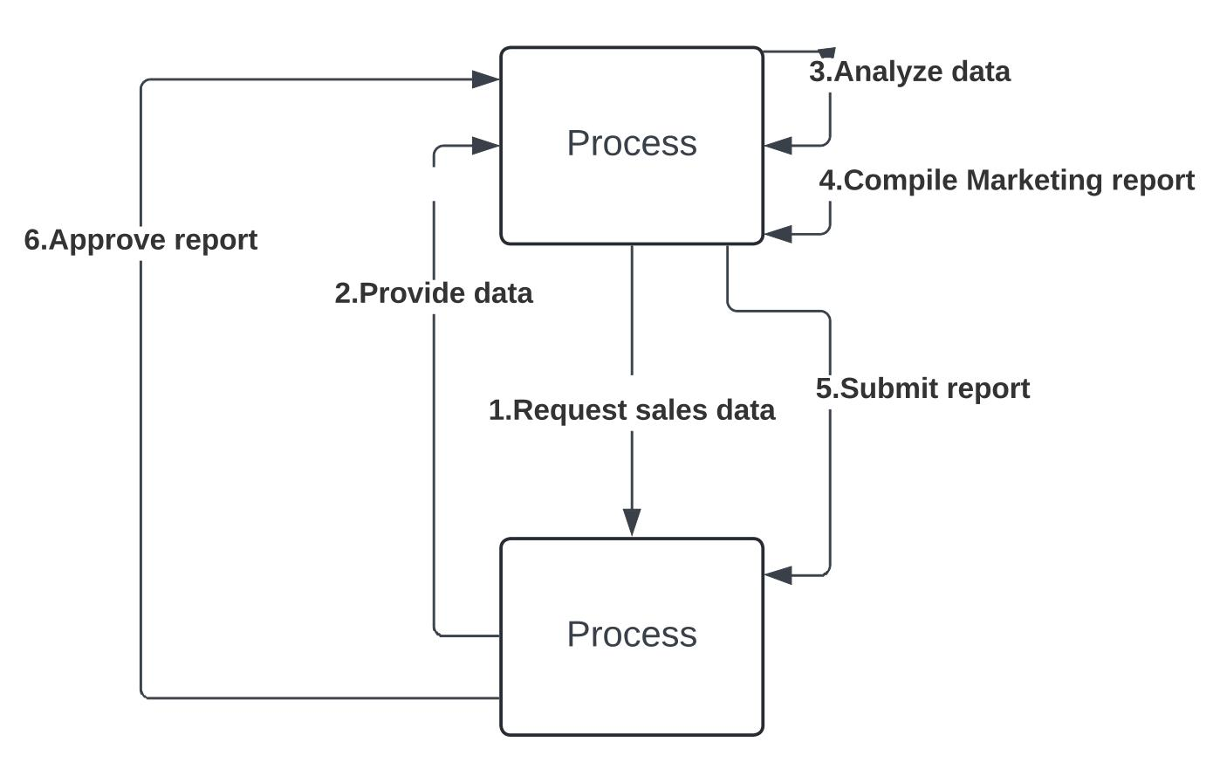

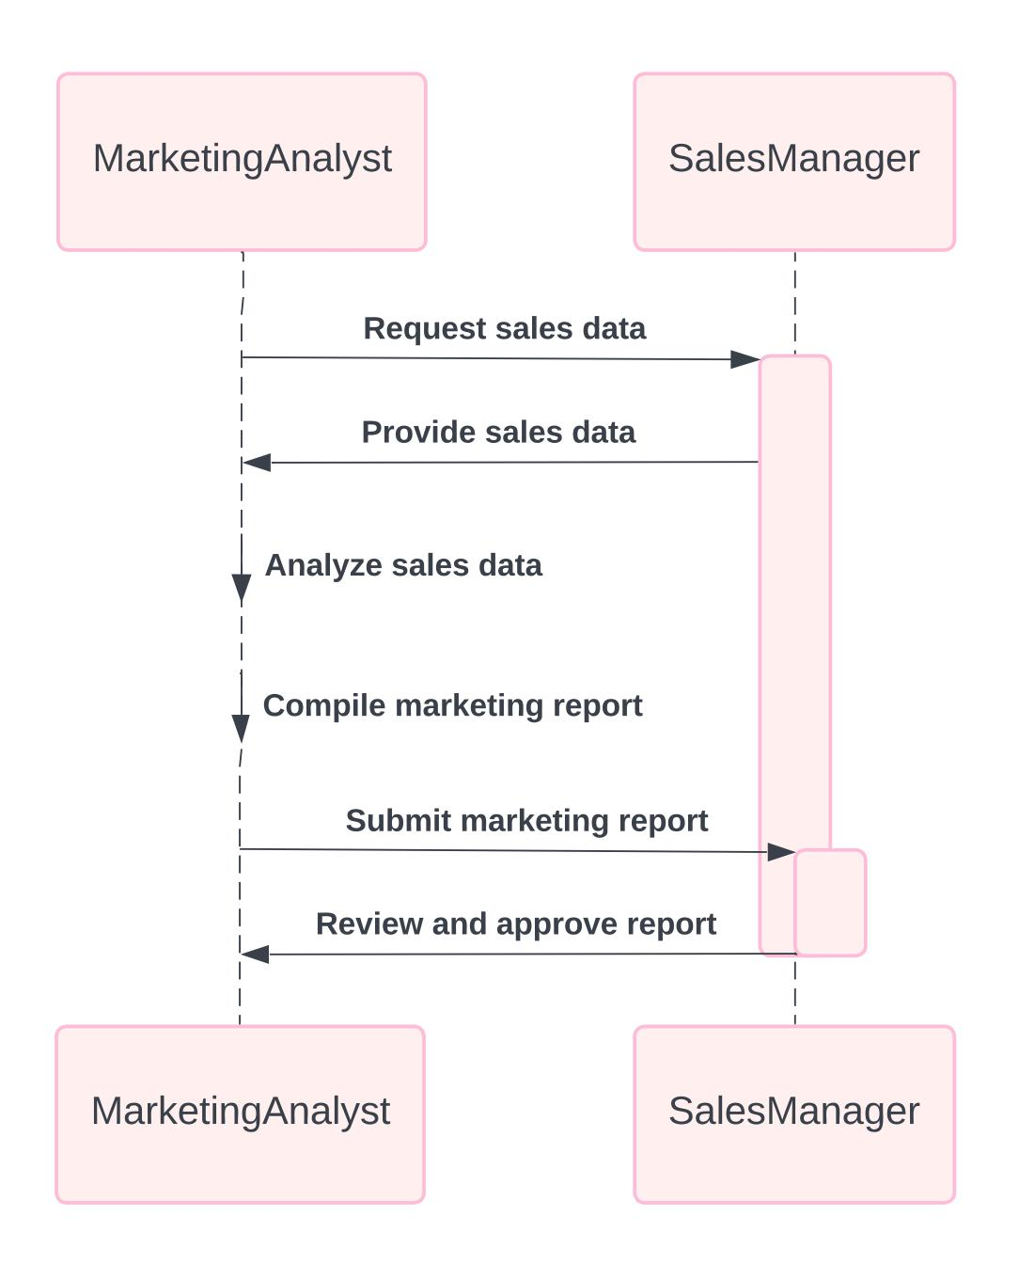

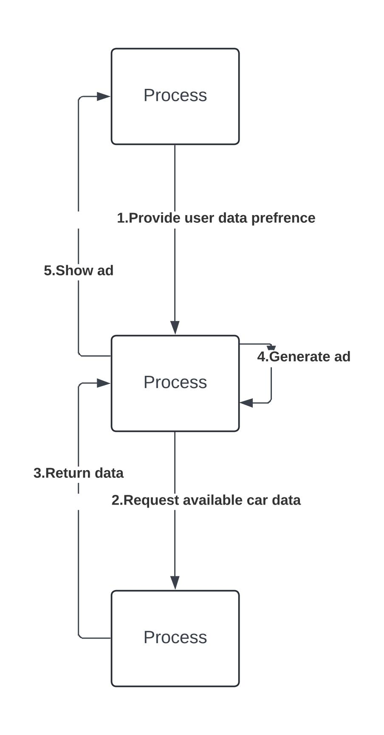

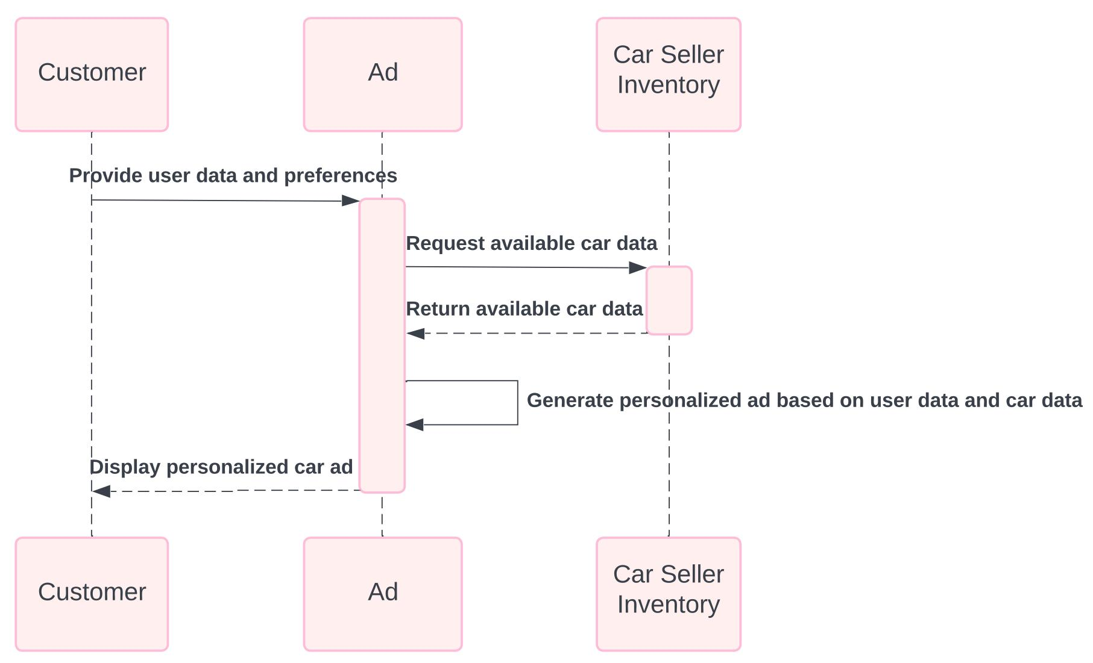

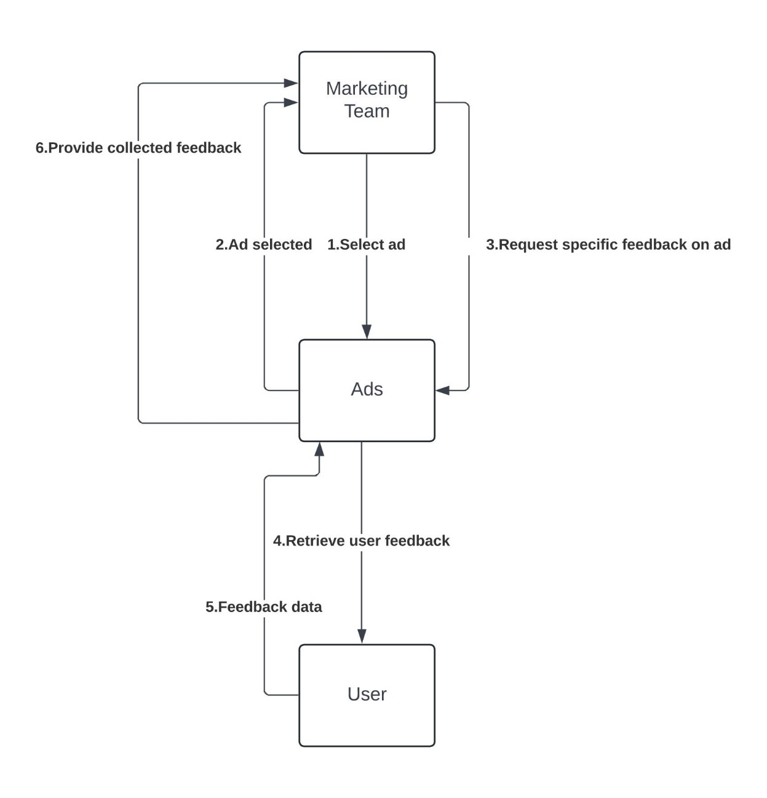

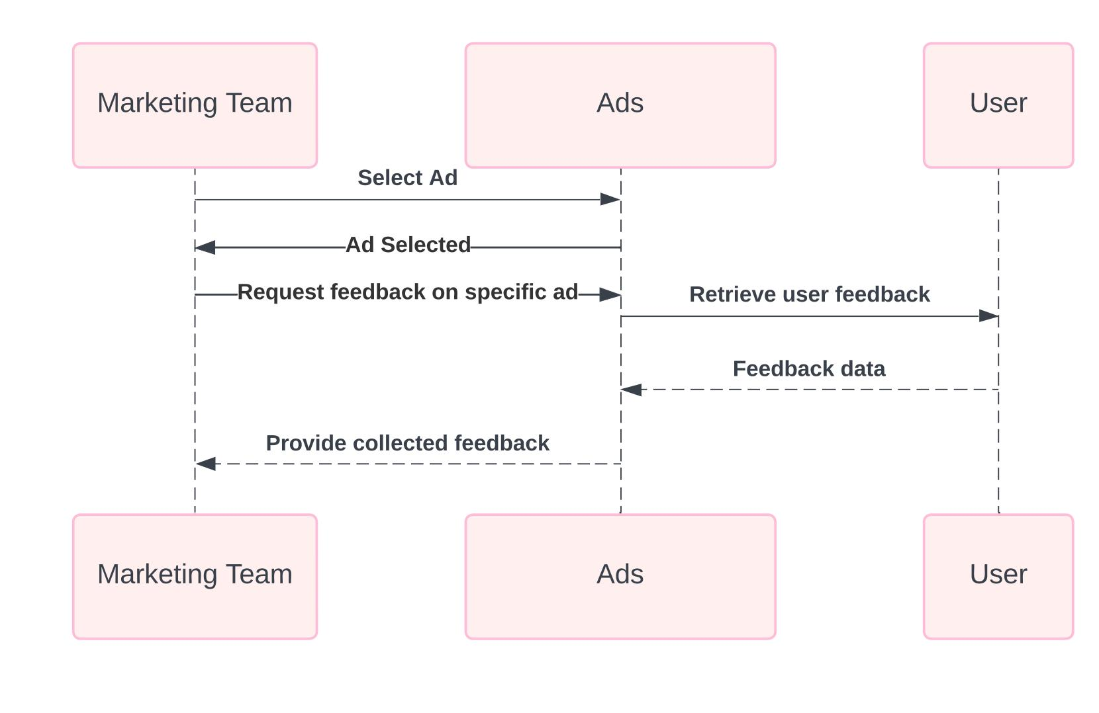

General Diagrams

Vehicle State & Order State

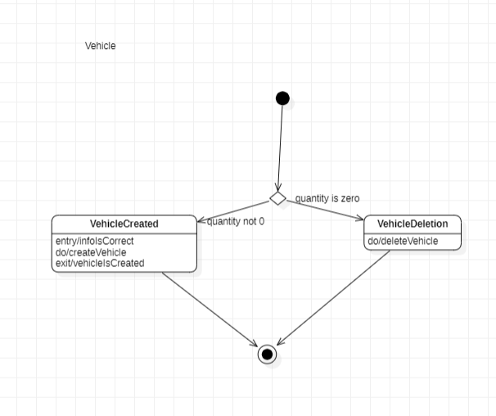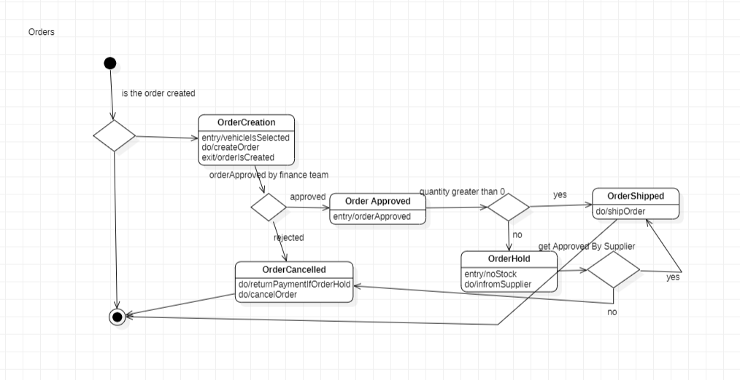

State Diagrams for each interface

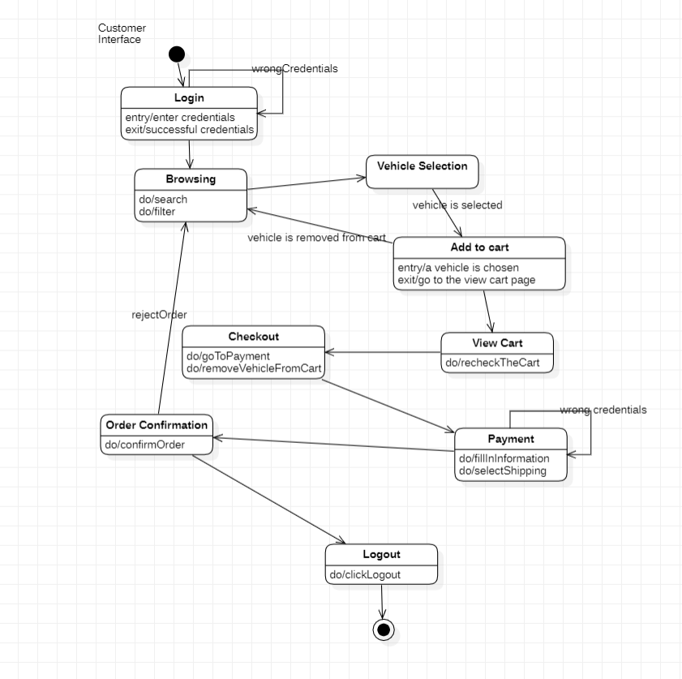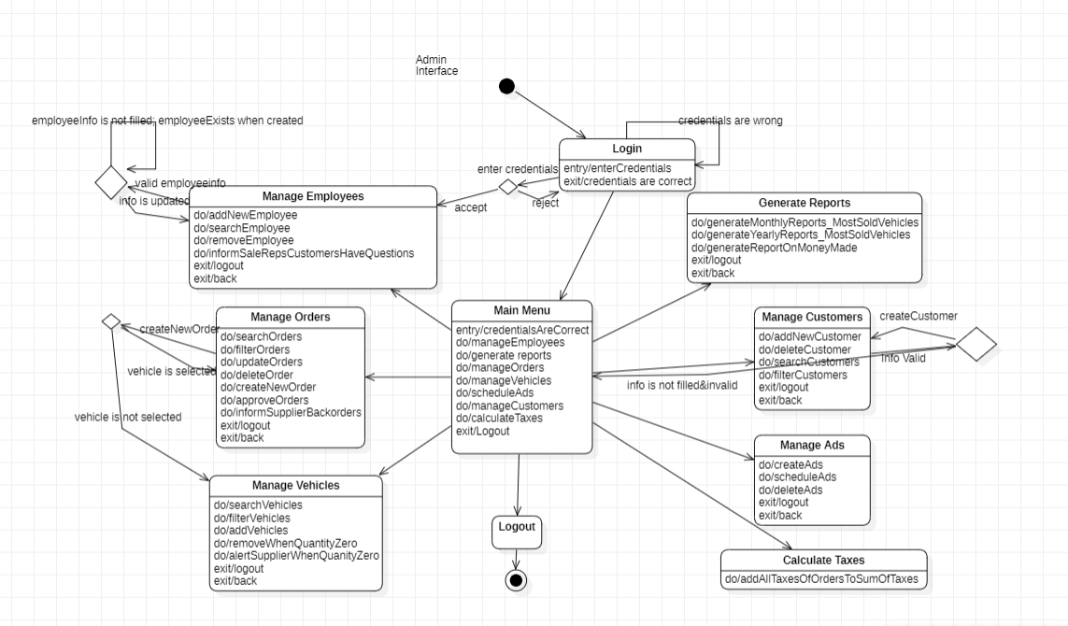

Use Case Diagram

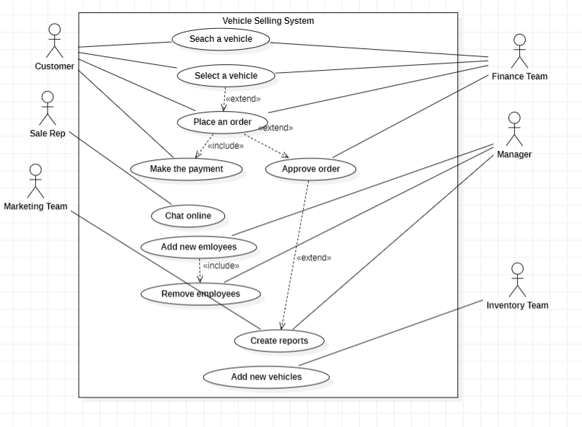

Class Diagram

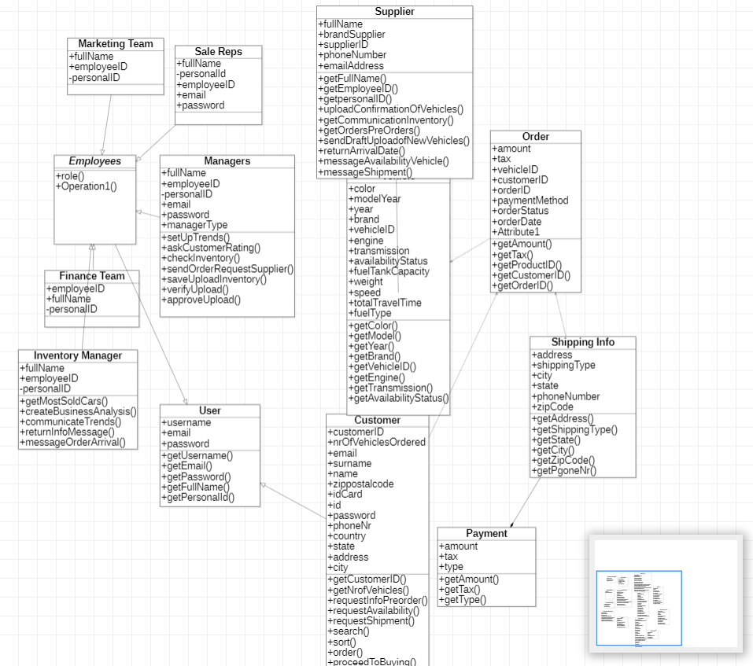

ER Diagram

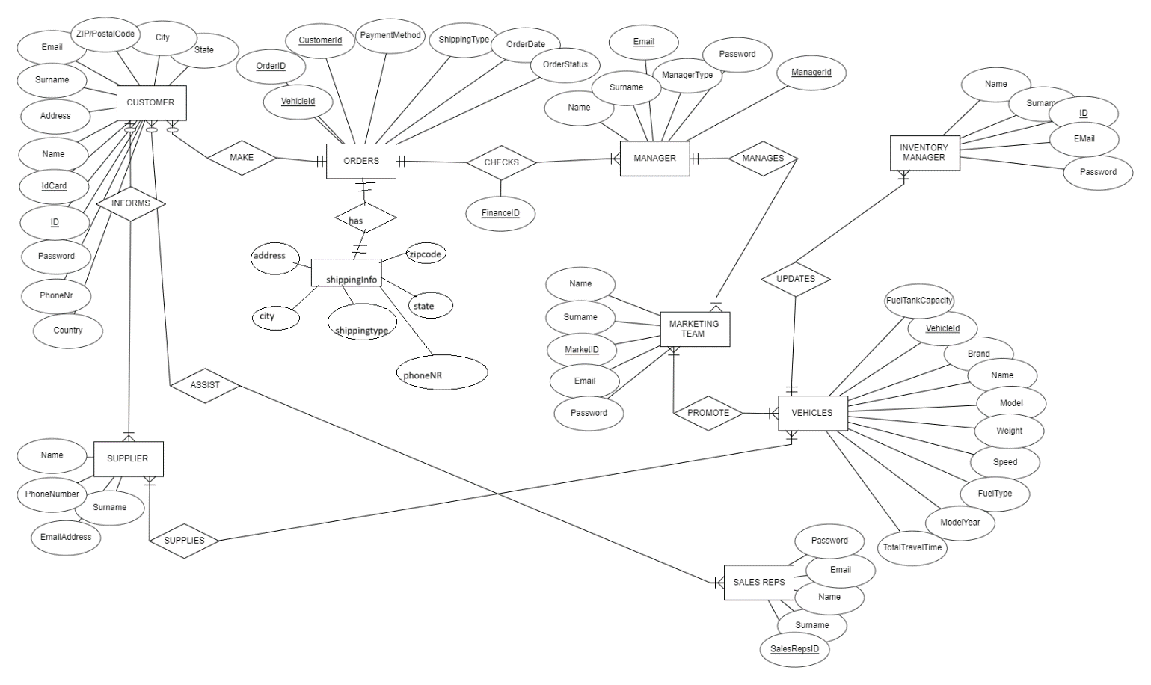

DATA FLOW DIAGRAM

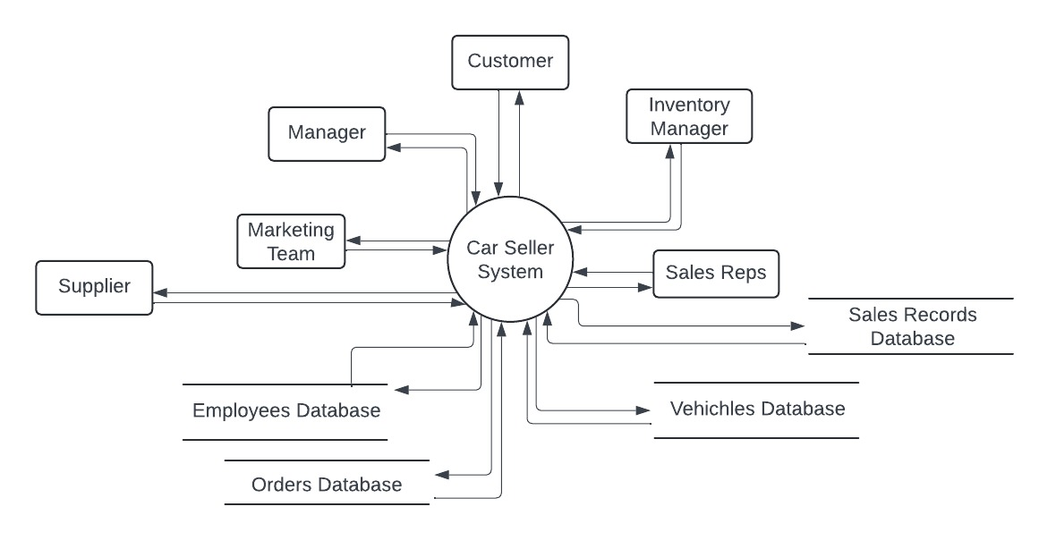

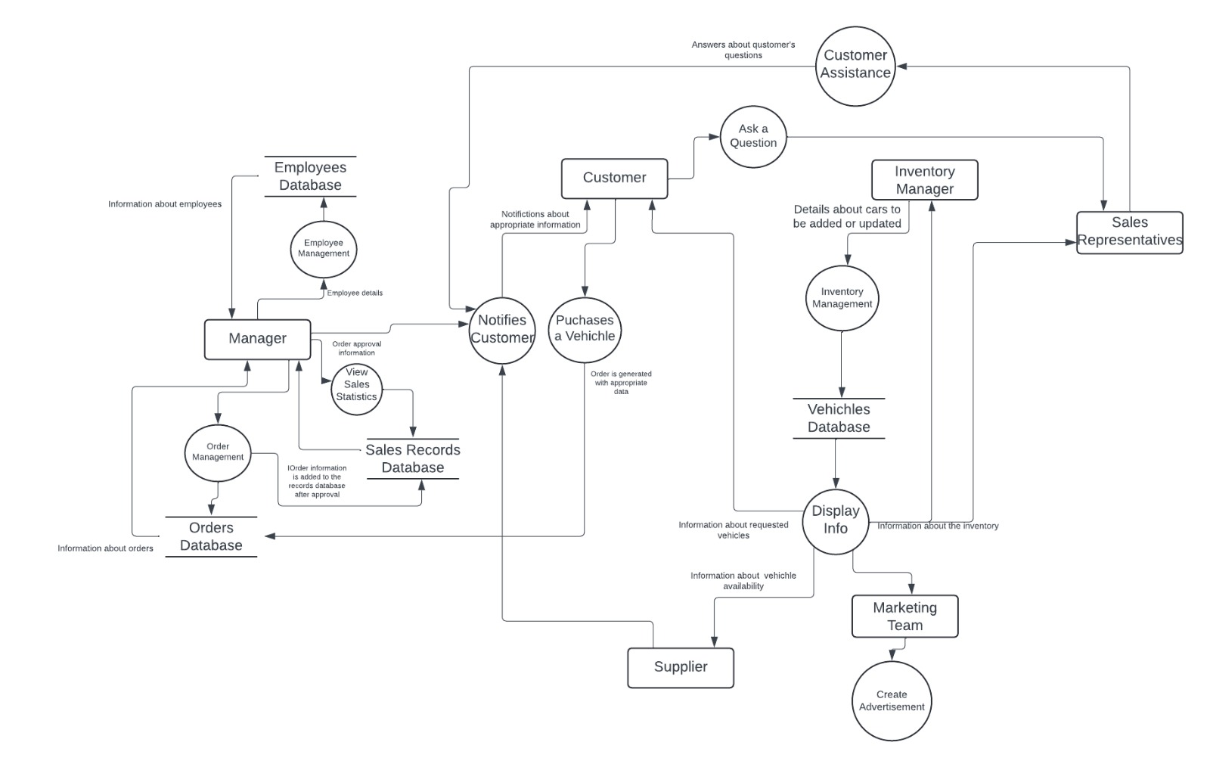

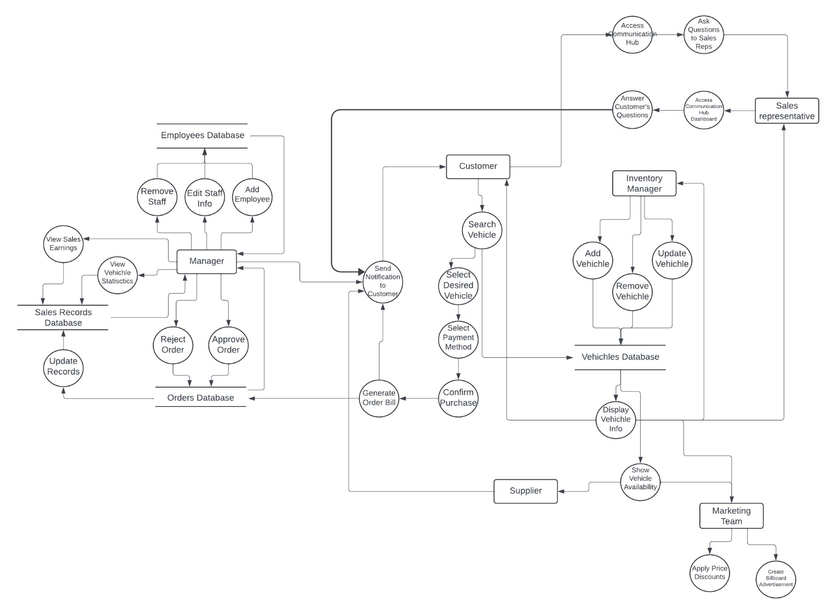

BUSINESS PROCESS MODELLING AND NOTATION DIAGRAM

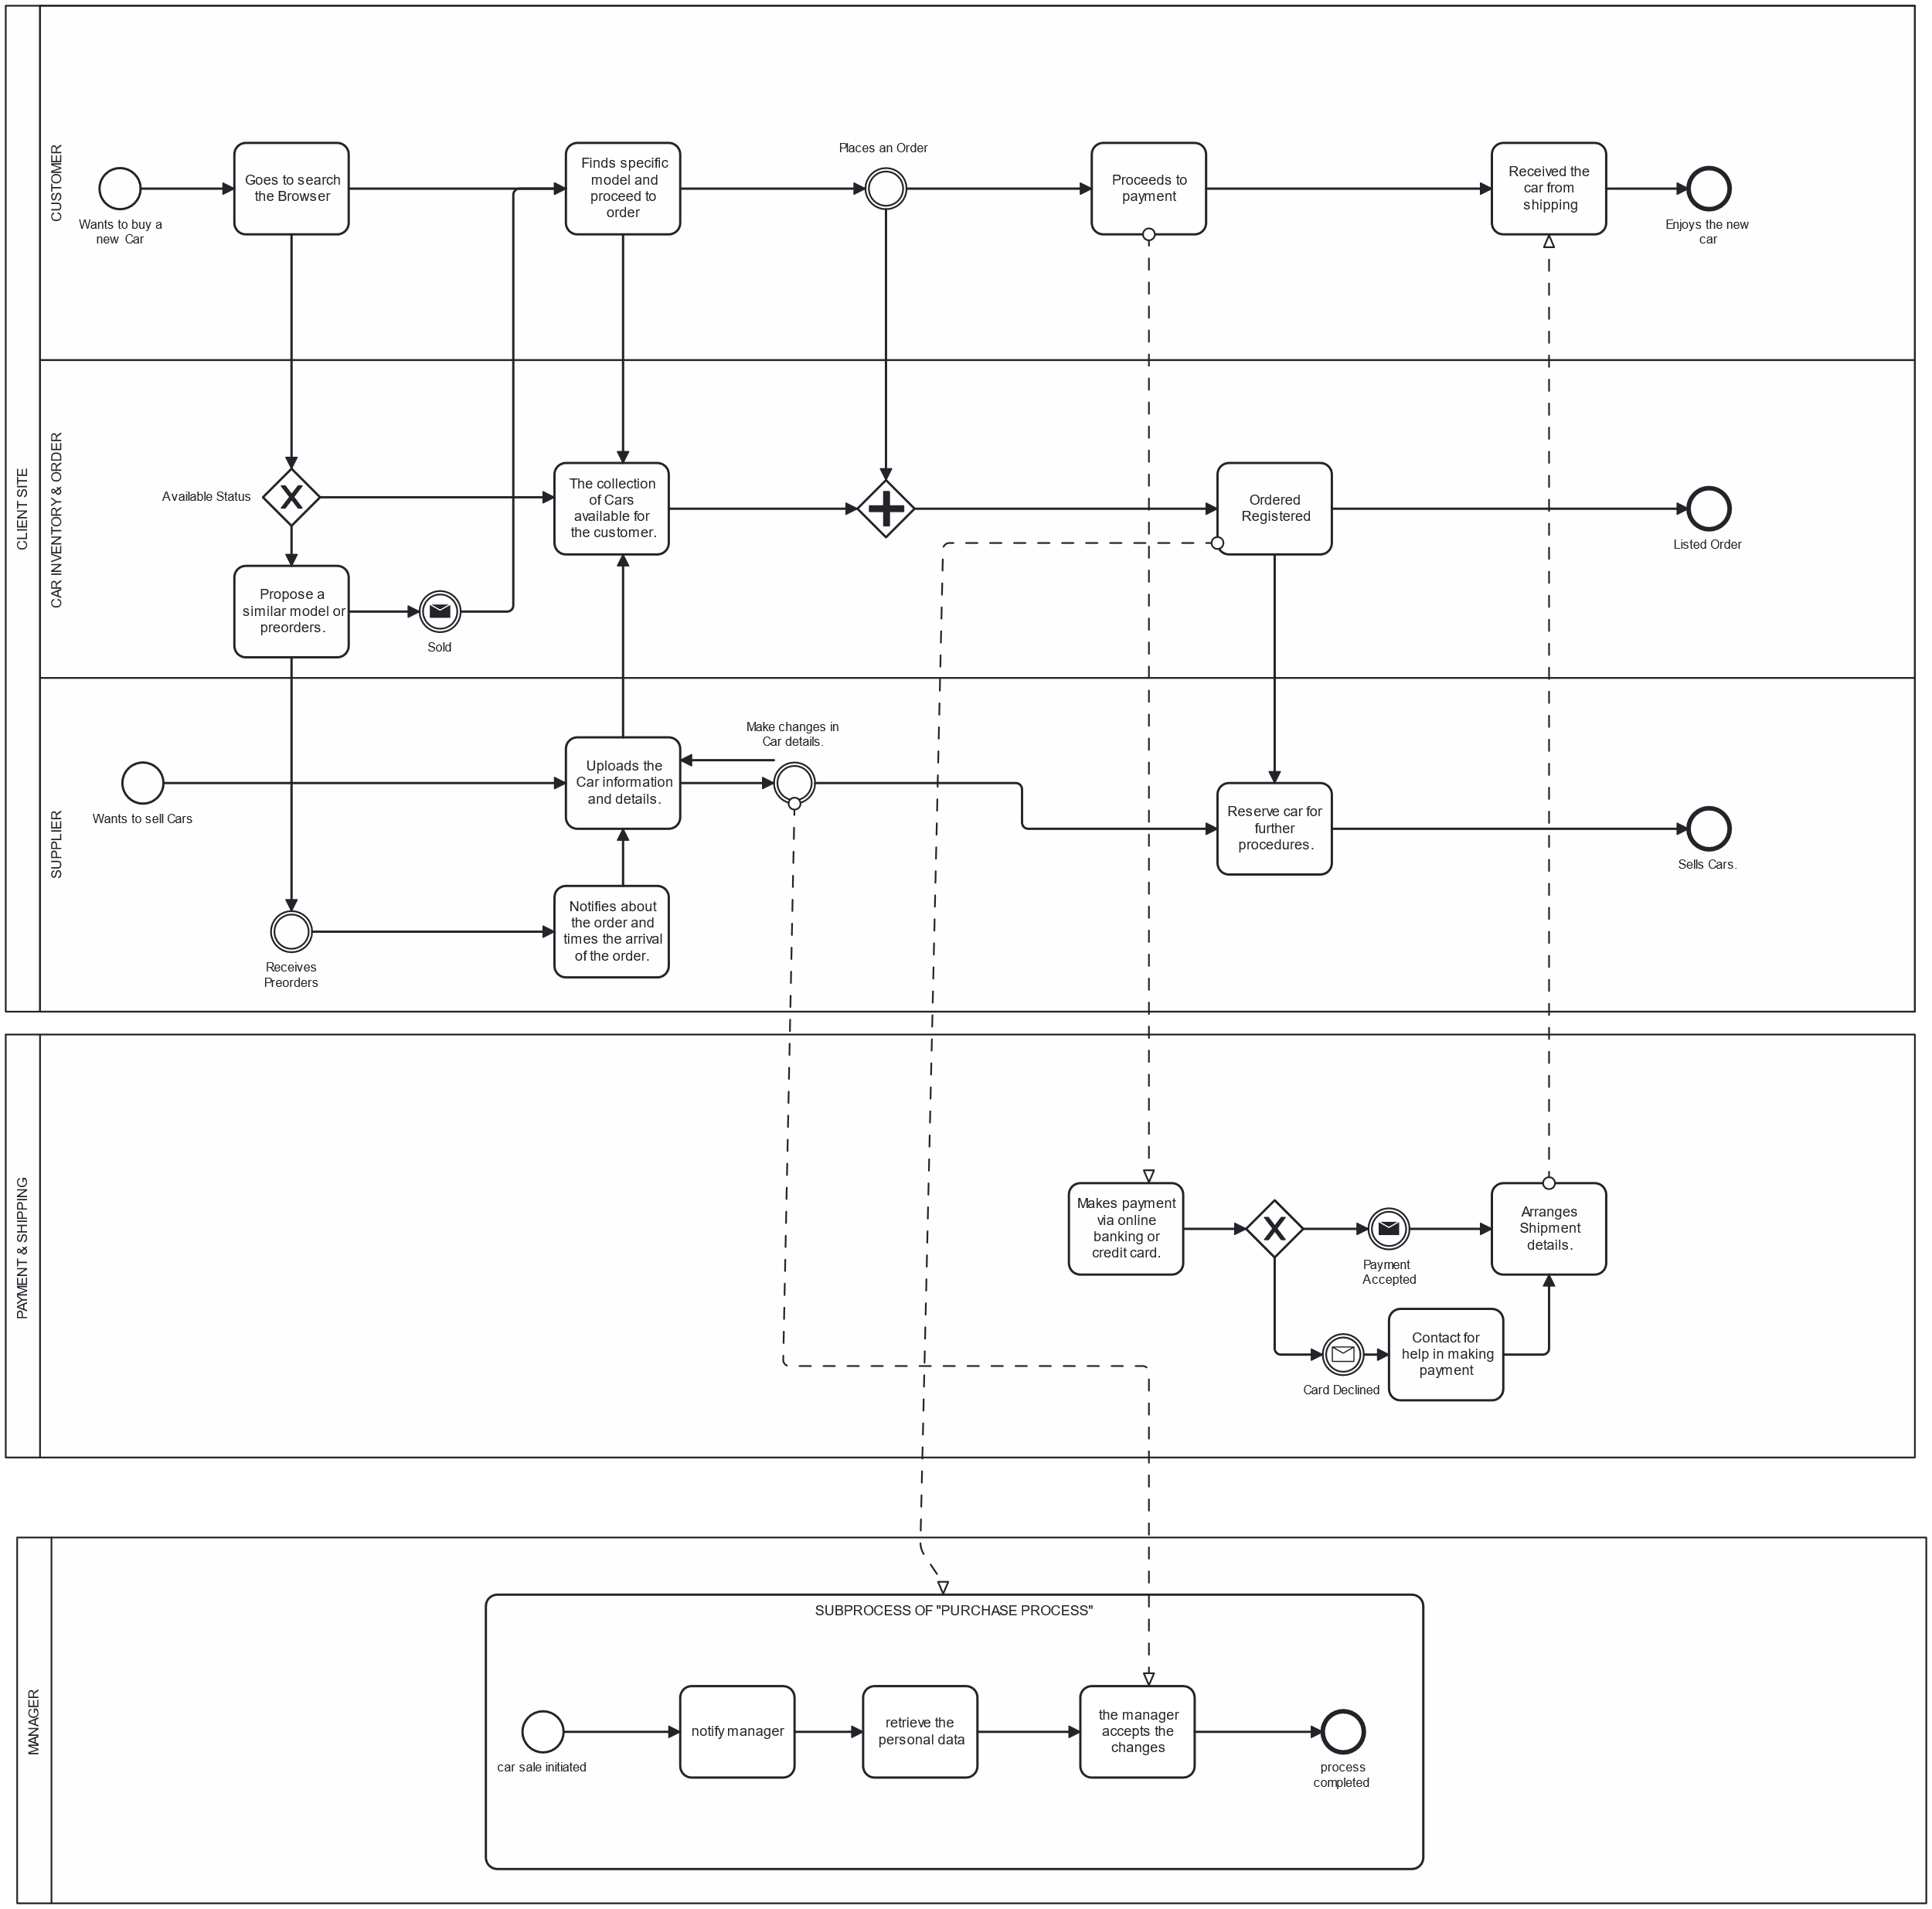

DESIGN PATTERNS

Builder Design Pattern

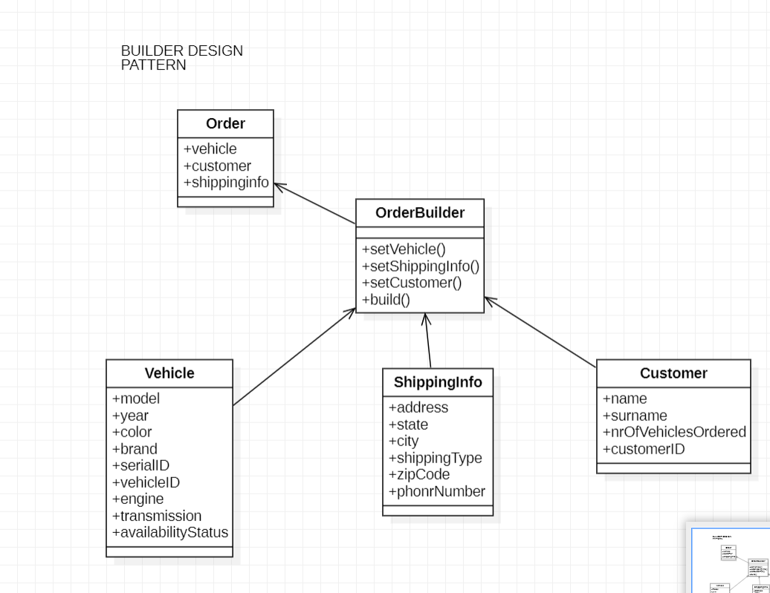

Composite Design Pattern

